Practical no 1
Aim:- Configure IP SLA Tracking and Path Control.
Topology
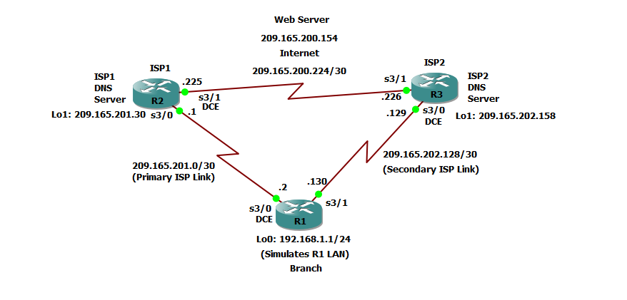

Step 1: Prepare the routers and configure the router hostname and interface addresses.
- Cable the network as shown in the topology diagram. Erase the startup configuration and reload each router to clear the previous configurations. Using the addressing scheme in the diagram, create the loopback interfaces and apply IP addresses to them as well as the serial interfaces on R1, ISP1, and ISP2.
You can copy and paste the following configurations into your routers to begin.
Router R1
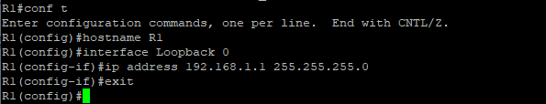
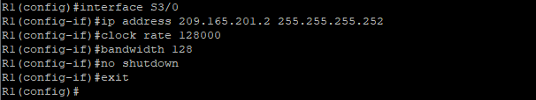
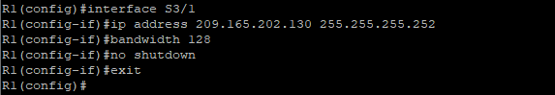
Router ISP1 (R2)
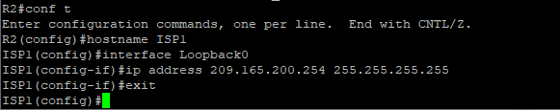
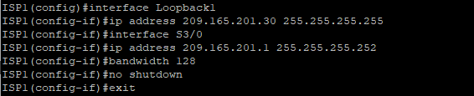
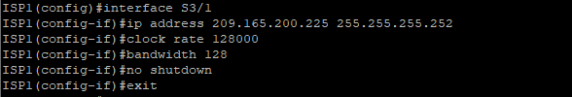
Router ISP2 (R3)
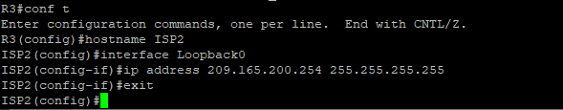
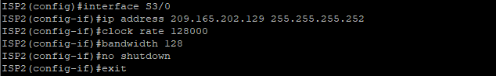
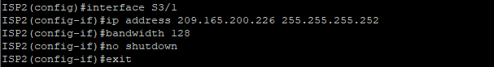
- Verify the configuration by using the show interfaces description command. The output from router R1 is shown here as an example.
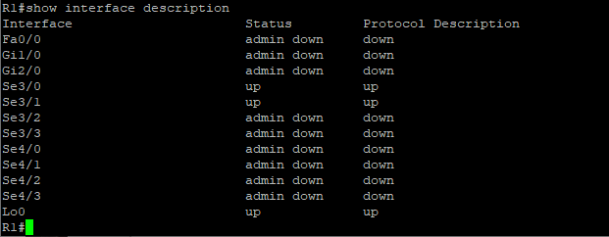
All three interfaces should be active. Troubleshoot if necessary.
c. The current routing policy in the topology is as follows:
• Router R1 establishes connectivity to the Internet through ISP1 using a default static route.
• ISP1 and ISP2 have dynamic routing enabled between them, advertising their respective public address pools.
• ISP1 and ISP2 both have static routes back to the ISP LAN.
Router R1
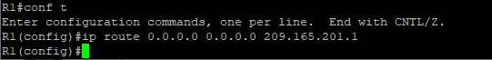
Router ISP1 (R2)
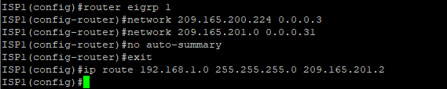

Router ISP2 (R3)
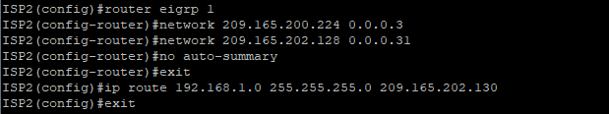
Step 2: Verify server reachability.
- Before implementing the Cisco IOS SLA feature, you must verify reachability to the Internet servers. From router R1, ping the web server, ISP1 DNS server, and ISP2 DNS server to verify connectivity. You can copy the following Tcl script and paste it intoR1.
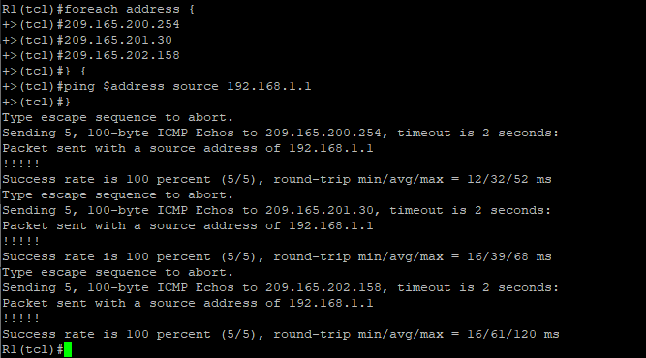

- Trace the path taken to the web server, ISP1 DNS server, and ISP2 DNS server. You can copy the following Tcl script and paste it into R1.
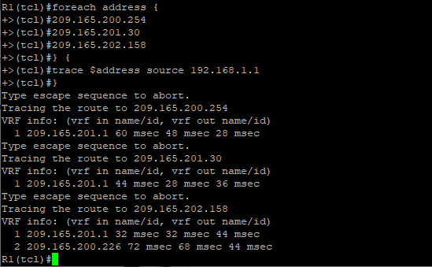
Step 3: Configure IP SLA probes.
- Create an ICMP echo probe on R1 to the primary DNS server on ISP1 using the ip sla command.
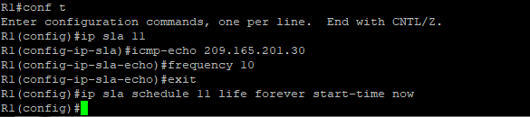
The operation number of 11 is only locally significant to the router. The frequency 10 command schedules the connectivity test to repeat every 10 seconds. The probe is scheduled to start now and to run forever.

- Verify the IP SLAs configuration of operation 11 using the show ip sla configuration 11 command.
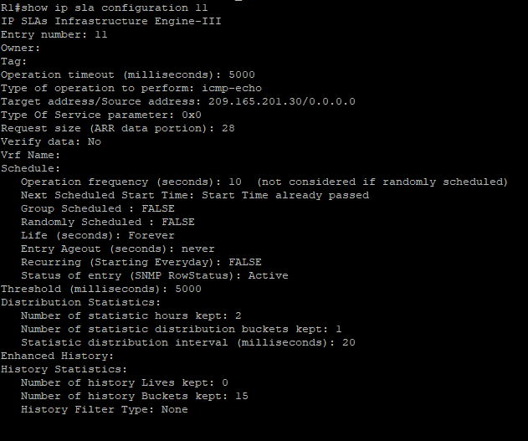
The output lists the details of the configuration of operation 11. The operation is an ICMP echo to 209.165.201.30, with a frequency of 10 seconds, and it has already started (the start time has already passed).

- Issue the show ip sla statistics command to display the number of successes, failures, and results of the latest operations.
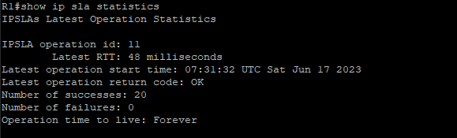
You can see that operation 11 has already succeeded five times, has had no failures, and the last operation returned an OK result.
- Although not actually required because IP SLA session 11 alone could provide the desired fault tolerance, create a second probe, 22, to test connectivity to the second DNS server located on router ISP2. You can copy and paste the following commands on R1.
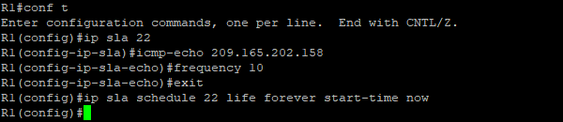

- Verify the new probe using the show ip sla configuration and show ip sla statistics commands.
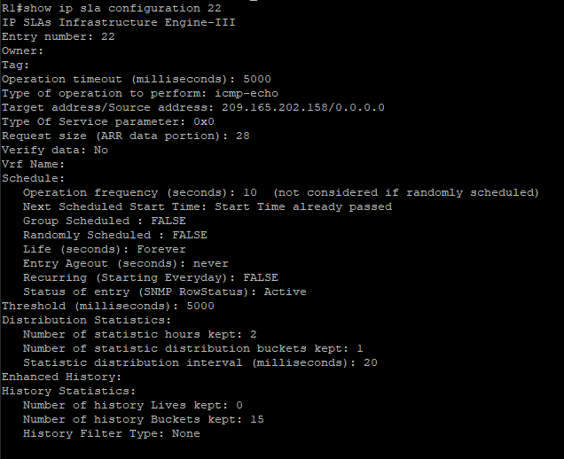
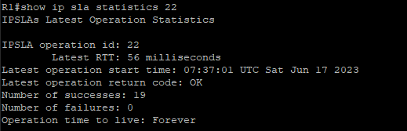
The output lists the details of the configuration of operation 22. The operation is an ICMP echo to 209.165.202.158, with a frequency of 10 seconds, and it has already started (the start time has already passed). The statistics also prove that operation 22 is active.

Step 4: Configure tracking options.
Although PBR could be used, you will configure a floating static route that appears or disappears depending on the success or failure of the IP SLA.
- Remove the current default route on R1, and replace it with a floating static route having an administrative distance of 5.
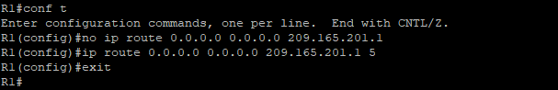
- Verify the routing table.
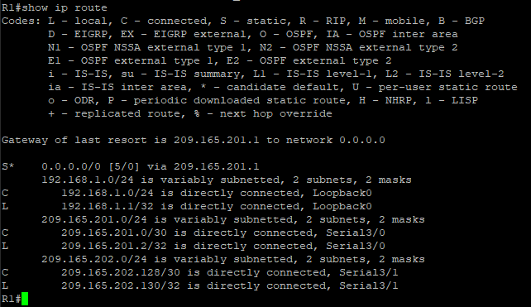
- Use the track 1 ip sla 11 reachability command to enter the config-track subconfiguration mode.
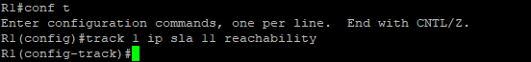

- Specify the level of sensitivity to changes of tracked objects to 10 seconds of down delay and 1 second of up delay using the delay down 10 up 1 command. The delay helps to alleviate the effect of flapping objects—objects that are going down and up rapidly. In this situation, if the DNS server fails momentarily and comes back up within 10 seconds, there is no impact.
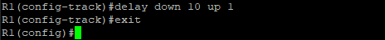
- Configure the floating static route that will be implemented when tracking object 1 is active. To view routing table changes as they happen, first enable the debug ip routing command. Next, use the ip route 0.0.0.0 0.0.0.0 209.165.201.1 2 track 1 command to create a floating static default route via 209.165.201.1 (ISP1). Notice that this command references the tracking object number 1, which in turn references IP SLA operation number 11.
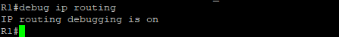
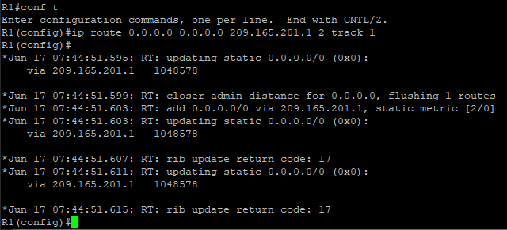
- Repeat the steps for operation 22, track number 2, and assign the static route an admin distance higher than track 1 and lower than 5. On R1, copy the following configuration, which sets an admin distance of 3.
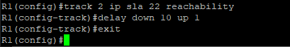
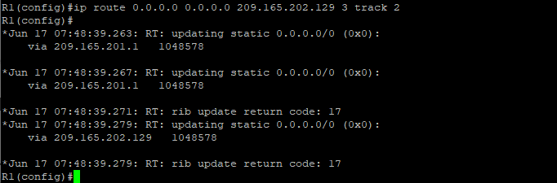
- Verify the routing table again.
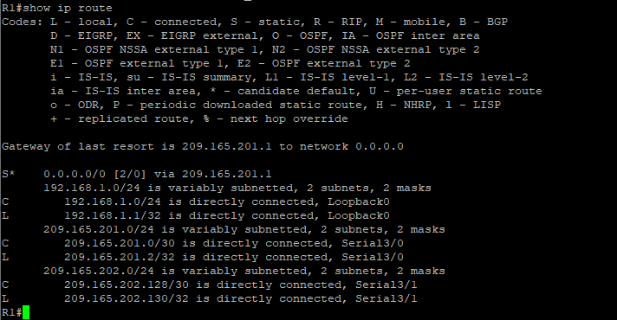
Although a new default route was entered, its administrative distance is not better than 2. Therefore, it does not replace the previously entered default route.
Step 5: Verify IP SLA operation.
In this step you observe and verify the dynamic operations and routing changes when tracked objects fail.The following summarizes the process:
• Disable the DNS loopback interface on ISP1 (R2).
• Observe the output of the debug command on R1.
• Verify the static route entries in the routing table and the IP SLA statistics of R1.
• Re-enable the loopback interface on ISP1 (R2) and again observe the operation of the IP SLA tracking feature.
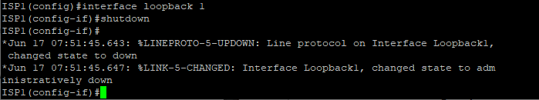
- Shortly after the loopback interface is administratively down, observe the debug output being generatedon R1.
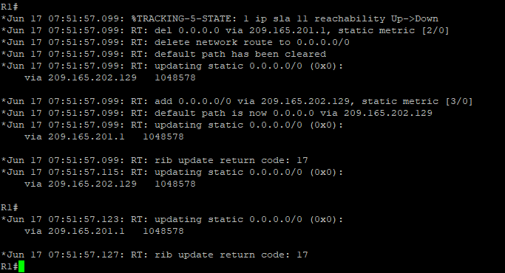
The tracking state of track 1 changes from up to down. This is the object that tracked reachability for IP SLA object 11, with an ICMP echo to the ISP1 DNS server at 209.165.201.30.
R1 then proceeds to delete the default route with the administrative distance of 2 and installs the next highest default route to ISP2 with the administrative distance of 3.

- On R1, verify the routing table.
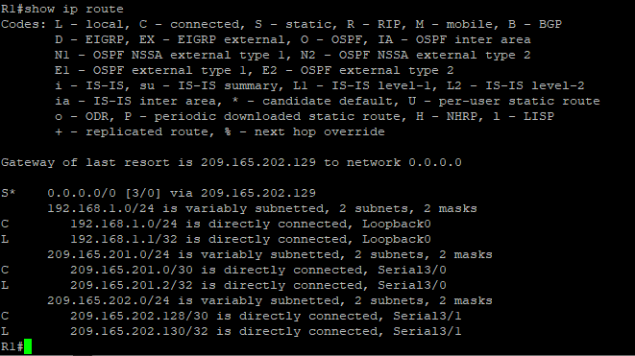
The new static route has an administrative distance of 3 and is being forwarded to ISP2 as it should.
- Verify the IP SLA statistics.
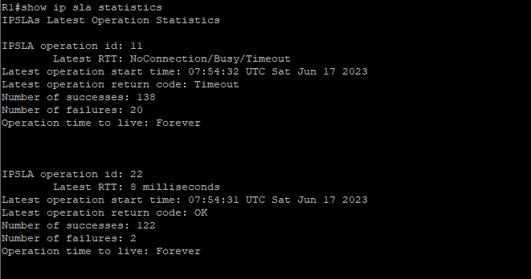

- On R1, initiate a trace to the web server from the internal LAN IP address.
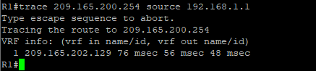
This confirms that traffic is leaving router R1 and being forwarded to the ISP2 router.
- On ISP1, re-enable the DNS address by issuing the no shutdown command on the loopback 1 interface to examine the routing behavior when connectivity to the ISP1 DNS is restored.
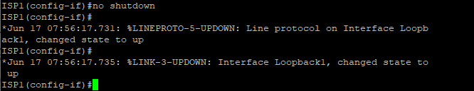
Notice the output of the debug ip routing command on R1.
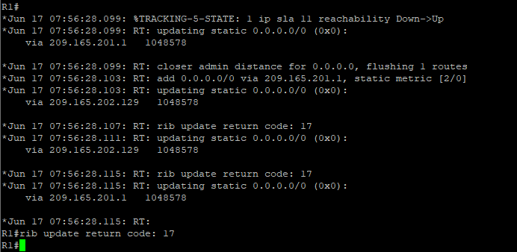
Now the IP SLA 11 operation transitions back to an up state and reestablishes the default static route to ISP1 with an administrative distance of 2.

- Again examine the IP SLA statistics.
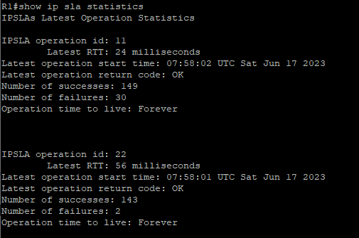
The IP SLA 11 operation is active again, as indicated by the OK return code, and the number of successes is incrementing.
- Verify the routing table.
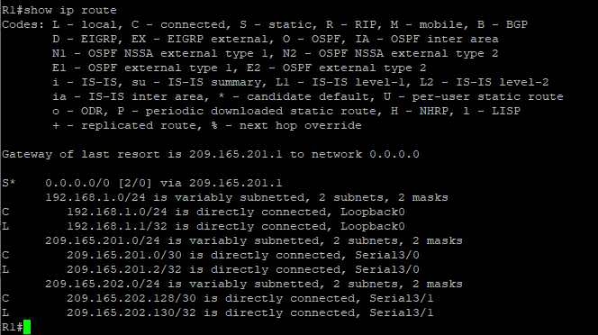
The default static through ISP1 with an administrative distance of 2 is restablished.
Practical no 2
Aim:- Using the AS_PATH Attribute.
Topology
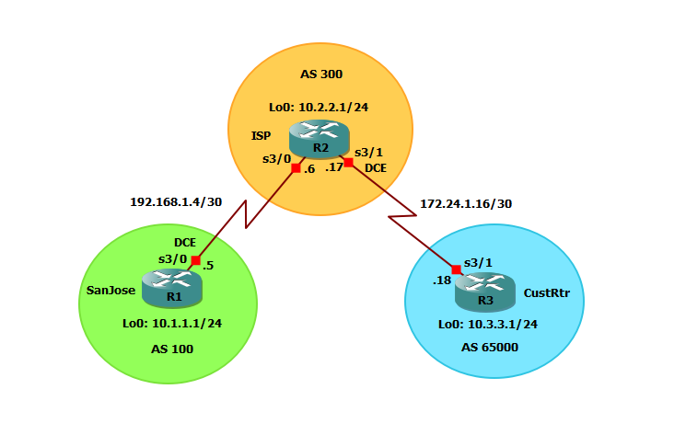

Step 1: Prepare the routers for the lab.
Cable the network as shown in the topology diagram. Erase the startup configuration and reload each router to clear previous configurations.

Step 2: Configure the hostname and interface addresses.
a. You can copy and paste the following configurations into your routers to begin.
Router R1 (hostname SanJose)
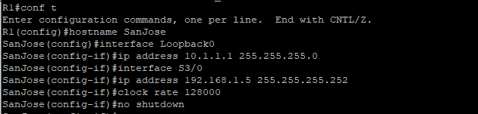
Router R2 (hostname ISP)
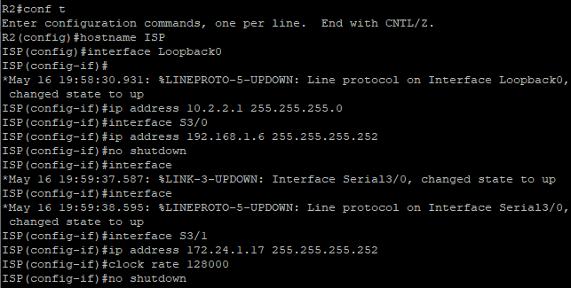
Router R3 (hostname CustRtr)
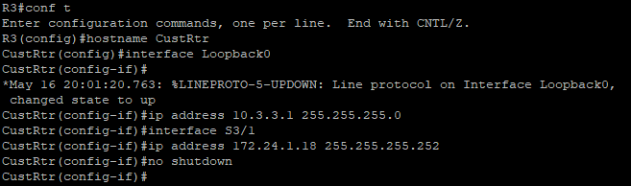

Step 3: Configure BGP.
- Configure BGP for normal operation. Enter the appropriate BGP commands on each router so that they identify their BGP neighbors and advertise their loopback networks.
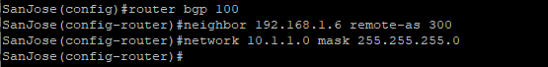
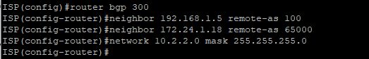
- Verify that these routers have established the appropriate neighbor relationships by issuing the show ip bgp neighbors command on each router.
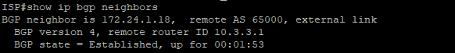
<output omitted>
<output omitted>

Step 4: Remove the private AS.
- Display the SanJose routing table using the show ip route command. SanJose should have a route to both 10.2.2.0 and 10.3.3.0. Troubleshoot if necessary.

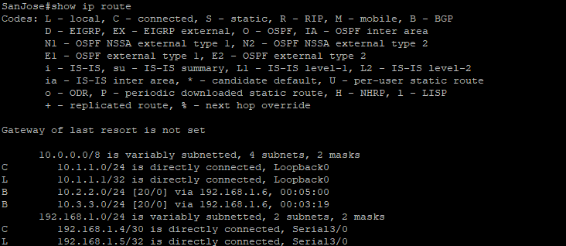

- Ping again, this time as an extended ping, sourcing from the Loopback0 interface address.

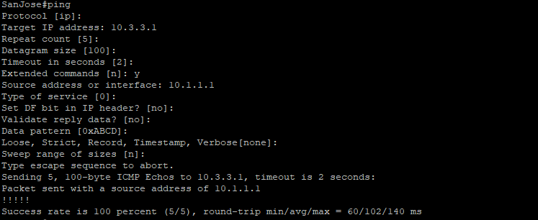

- Check the BGP table from SanJose by using the show ip bgp command. Note the AS path for the 10.3.3.0 network. The AS 65000 should be listed in the path to 10.3.3.0.

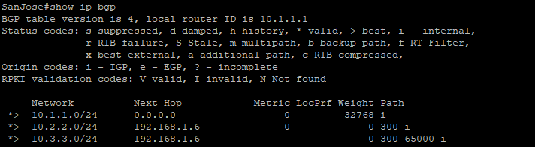

- Configure ISP to strip the private AS numbers from BGP routes exchanged with SanJose using the following commands.

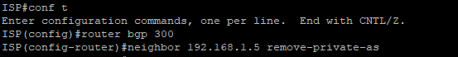

- SanJose should be able to ping 10.3.3.1 using its loopback 0 interface as the source of the ping.

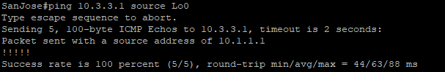

- Now check the BGP table on SanJose. The AS_ PATH to the 10.3.3.0 network should be AS 300. It no longer has the private AS in the path.

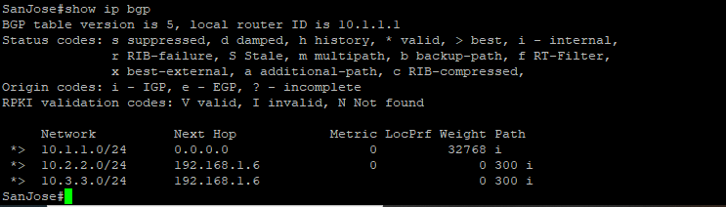

Step 5: Use the AS_PATH attribute to filter routes.

- Configure a special kind of access list to match BGP routes with an AS_PATH attribute that both begins and ends with the number 100. Enter the following commands on ISP.
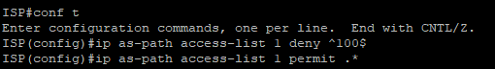

- Apply the configured access list using the neighbor command with the filter-list option.

- Use the clear ip bgp * command to reset the routing information. Wait several seconds and then check the routing table for ISP. The route to 10.1.1.0 should be in the routing table.

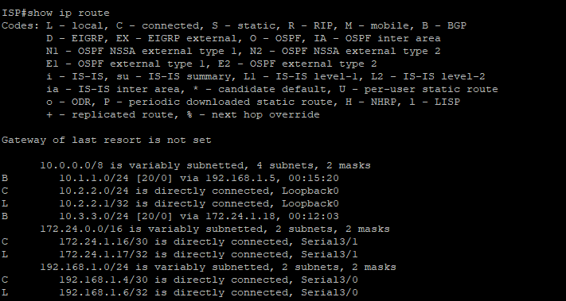

- Check the routing table for CustRtr. It should not have a route to 10.1.1.0 in its routing table.

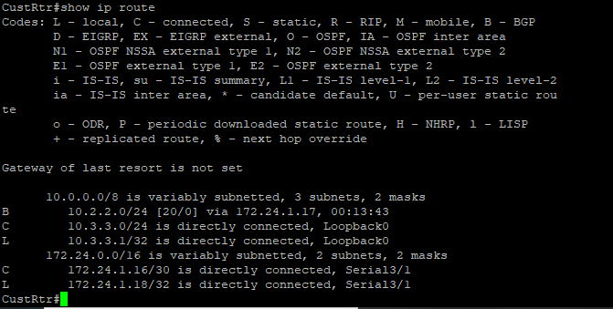

- Return to ISP and verify that the filter is working as intended. Issue the show ip bgp regexp ^100$ command.

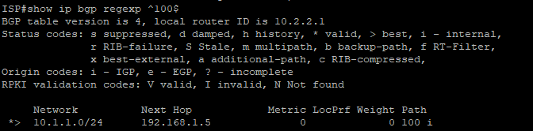

- Run the following Tcl script on all routers to verify whether there is connectivity. All pings from ISP should be successful. SanJose should not be able to ping the CustRtr loopback 10.3.3.1 or the WAN link 172.24.1.16/30. CustRtr should not be able to ping the SanJose loopback 10.1.1.1 or the WAN link 192.168.1.4/30.

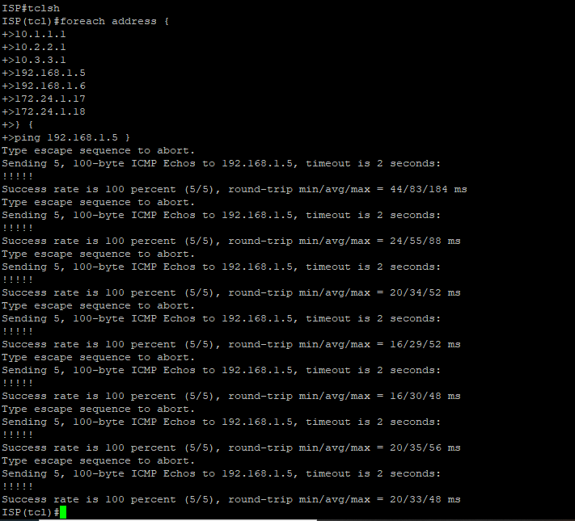

Practical no 3
Aim:- Configuring IBGP and EBGP Sessions, Local Preference and MED
Topology
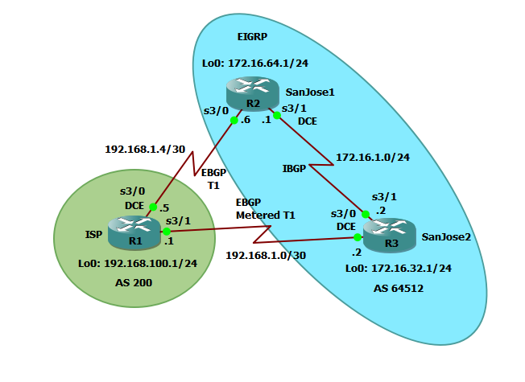

Step 0: Suggested starting configurations.
a. Apply the following configuration to each router along with the appropriate hostname. The exec-timeout 0 0 command should only be used in a lab environment.
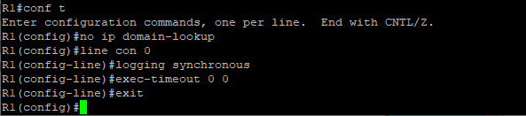
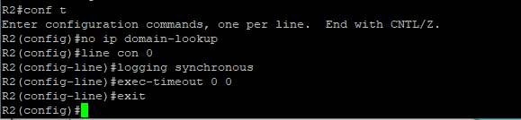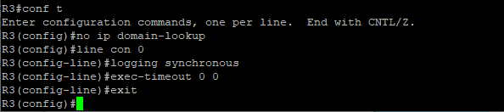
Step 1: configure interface addresses.
a. Using the addressing scheme in the diagram, create the loopback interfaces and apply IPv4 addresses to these and the serial interfaces on ISP (R1), SanJose1 (R2), and SanJose2 (R3).
Router R1 (hostname ISP)
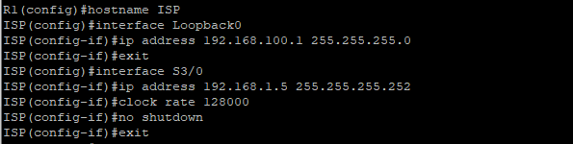
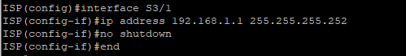
Router R2 (hostname SanJose1)
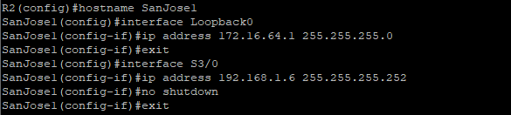
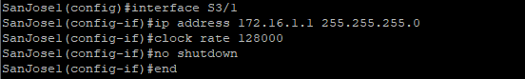
Router R3 (hostname SanJose2)
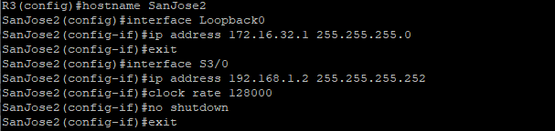
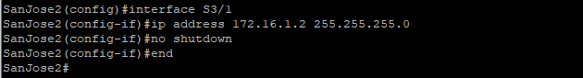
- Use ping to test the connectivity between the directly connected routers. Both SanJose routers should be able to ping each other and their local ISP serial link IP address. The ISP router cannot reach the segment between SanJose1 and SanJose2.
Step 2: Configure EIGRP.
Configure EIGRP between the SanJose1 and SanJose2 routers. (Note: If using an IOS prior to 15.0, use the no auto-summary router configuration command to disable automatic summarization. This command is the default beginning with IOS 15.)
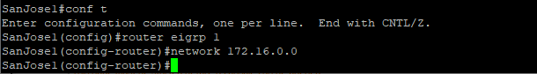
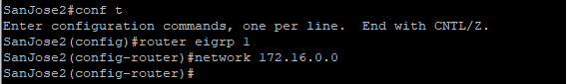

Step 3: Configure IBGP and verify BGP neighbors.
- Configure IBGP between the SanJose1 and SanJose2 routers. On the SanJose1 router, enter the following configuration.
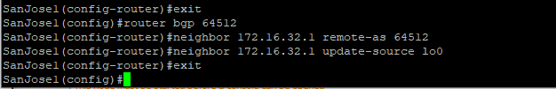
If multiple pathways to the BGP neighbor exist, the router can use multiple IP interfaces to communicate with the neighbor. The source IP address therefore depends on the outgoing interface. The update-source lo0 command instructs the router to use the IP address of the interface Loopback0 as the source IP address for all BGP messages sent to that neighbor.
- Complete the IBGP configuration on SanJose2 using the following commands.
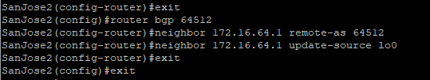
- Verify that SanJose1 and SanJose2 become BGP neighbors by issuing the show ip bgp neighbors command on SanJose1. View the following partial output. If the BGP state is not established, troubleshoot the connection.
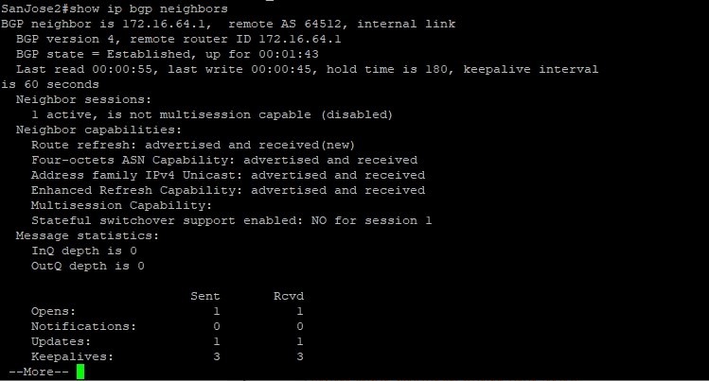
<Output Omitted>
The link between SanJose1 and SanJose2 should be identified as an internal link indicating an IBGP peering relationship, as shown in the output.

Step 4: Configure EBGP and verify BGP neighbors.
- Configure ISP to run EBGP with SanJose1 and SanJose2. Enter the following commands on ISP.
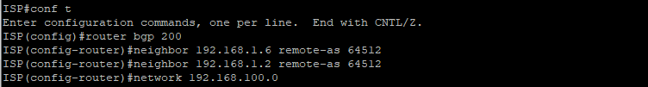
Because EBGP sessions are almost always established over point-to-point links, there is no reason to use the update-source keyword in this configuration. Only one path exists between the peers. If this path goes down, alternative paths are not available.

- Configure a discard static route for the 172.16.0.0/16 network. Any packets that do not have a more specific match (longer match) for a 172.16.0.0 subnet will be dropped instead of sent to the ISP. Later in this lab we will configure a default route to the ISP.
- Configure SanJose1 as an EBGP peer to ISP.

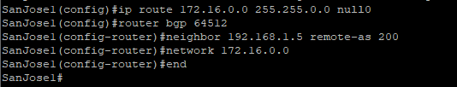

- Use the show ip bgp neighbors command to verify that SanJose1 and ISP have reached the established state. Troubleshoot if necessary.
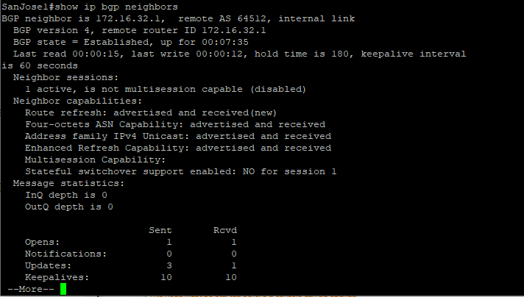
<Output Omitted>
e. Configure a discard static route for 172.16.0.0/16 on SanJose2 and as an EBGP peer to ISP.
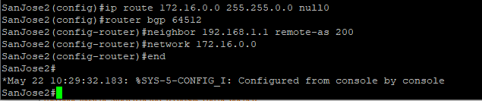

Step 5: View BGP summary output.
In Step 4, the show ip bgp neighbors command was used to verify that SanJose1 and ISP had reached the established state. A useful alternative command is show ip bgp summary. The output should be similar to the following.
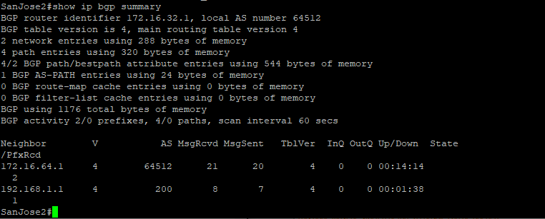
Step 6: Verify which path the traffic takes.
f.Clear the IP BGP conversation with the clear ip bgp * command on ISP. Wait for the conversations to reestablish with each SanJose router.
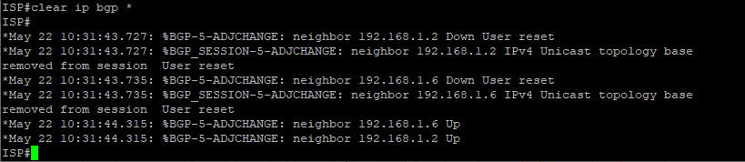
- Test whether ISP can ping the loopback 0 address of 172.16.64.1 on SanJose1 and the serial link between SanJose1 and SanJose2, 172.16.1.1
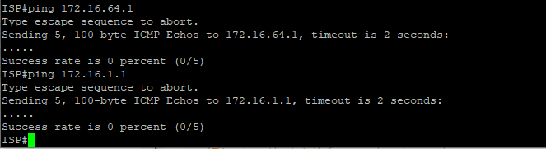

- Now ping from ISP to the loopback 0 address of 172.16.32.1 on SanJose2 and the serial link between SanJose1 and SanJose2, 172.16.1.2.
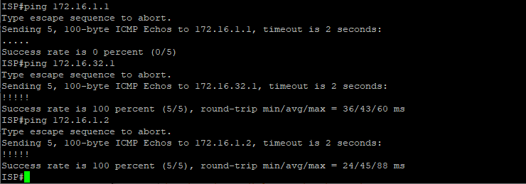
- Issue the show ip bgp command on ISP to verify BGP routes and metrics.

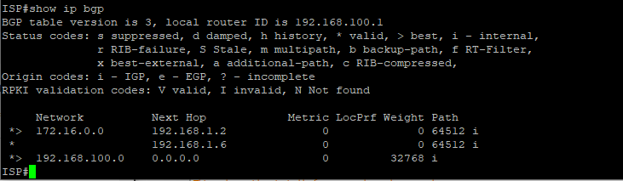

- At this point, the ISP router should be able to get to each network connected to SanJose1 and SanJose2 from the loopback address 192.168.100.1. Use the
extended ping command and specify the source address of ISP Lo0 to test.

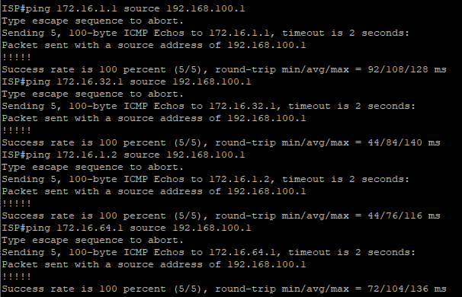

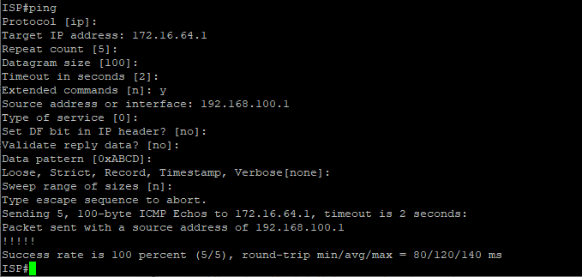

Complete reachability has been demonstrated between the ISP router and both SanJose1 and SanJose2.

Step 7: Configure the BGP next-hop-self feature.
SanJose1 is unaware of the link between ISP and SanJose2, and SanJose2 is unaware of the link between ISP and SanJose1. Before ISP can successfully ping all the internal serial interfaces of AS 64512, these serial links should be advertised via BGP on the ISP router. This can also be resolved via EIGRP on each SanJose router. One method is for ISP to advertise these links.
- Issue the following commands on the ISP router.
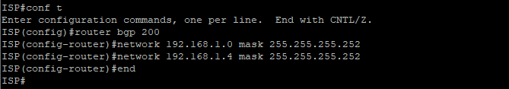
- Issue the show ip bgp command to verify that the ISP is correctly injecting its own WAN links into BGP.
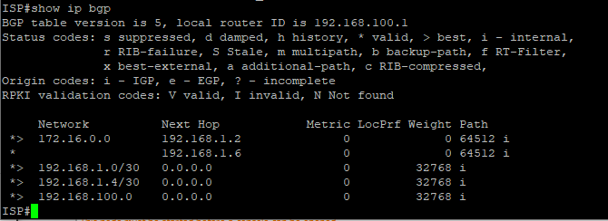

- Verify on SanJose1 and SanJose2 that the opposite WAN link is included in the routing table. The output from SanJose2 is as follows.
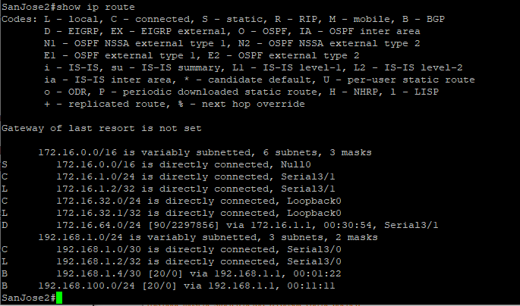
The next issue to consider is BGP policy routing between autonomous systems. The next-hop attribute of a route in a different AS is set to the IP address of the border router in the next AS toward the destination, and this attribute is not modified by default when advertising this route through IBGP. Therefore, for all IBGP peers, it is either necessary to know the route to that border router (in a different neighboring AS), or our own border router needs to advertise the foreign routes using the next-hop-self feature, overriding the next-hop address with its own IP address. The SanJose2 router is passing a policy to SanJose1 and vice versa. The policy for routing from AS 64512 to AS 200 is to forward packets to the 192.168.1.1 interface. SanJose1 has a similar yet opposite policy: it forwards requests to the 192.168.1.5 interface. If either WAN link fails, it is critical that the opposite router become a valid gateway. This is achieved if the next-hop-self command is configured on SanJose1 and SanJose2.

- To better understand the next-hop-self command we will remove ISP advertising its two WAN links and shutdown the WAN link between ISP and SanJose2. The only possible path from SanJose2 to ISP’s 192.168.100.0/24 is through SanJose1.

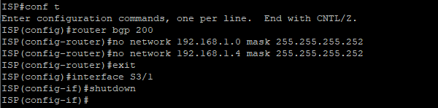
- Display SanJose2’s BGP table using the show ip bgp command and the IPv4 routing table with show ip route.

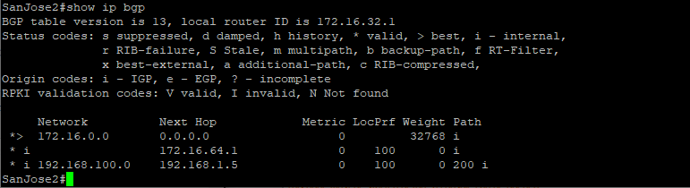
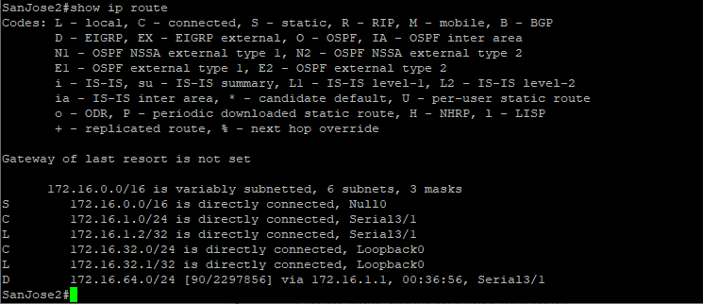

Notice that SanJose2 has 192.168.100.0 in it’s BGP table but not in its routing table. The BGP table shows the next hop to 192.168.100.0 as 192.168.1.5. Because SanJose2 does not have a route to this next hop address of 192.168.1.5 in its routing table, it will not install the 192.168.100.0 network into the routing table. It won’t install a route if it doesn’t know how to get to the next hop.
EBGP next hop addresses are carried into IBGP unchanged. As we saw previously, we could advertise the WAN link using BGP, but this is not always desirable. It means advertising additional routes when we are usually trying to minimize the size of the routing table. Another option is to have the routers within the IGP domain advertise themselves as the next hop router using the next-hop-self command.

- Issue the next-hop-self command on SanJose1 and SanJose2 to advertise themselves as the next hop to their IBGP peer.

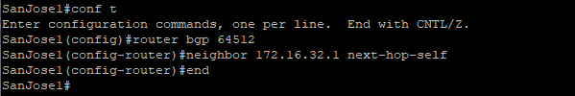
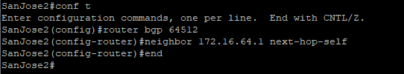

g. Reset BGP operation on either router with the clear ip bgp * command.

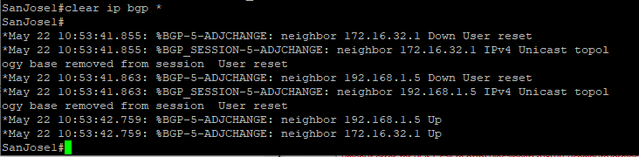
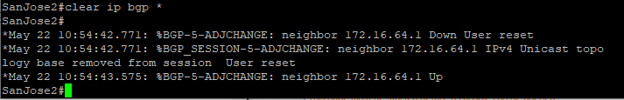

h. After the routers have returned to established BGP speakers, issue the show ip bgp command on SanJose2 and notice that the next hop is now SanJose1 instead of ISP.
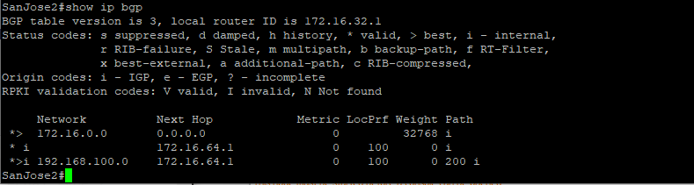i. The show ip route command on SanJose2 now displays the 192.168.100.0/24 network because SanJose1 is the next hop, 172.16.64.1, which is reachable from SanJose2.
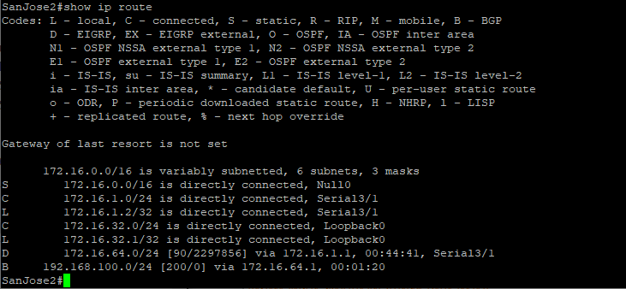
j.Before configuring the next BGP attribute, restore the WAN link between ISP and SanJose3. This will change the BGP table and routing table on both routers. For example, SanJose2’s routing table shows 192.168.100.0/24 will now have a better path through ISP.
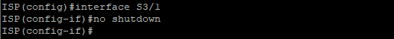
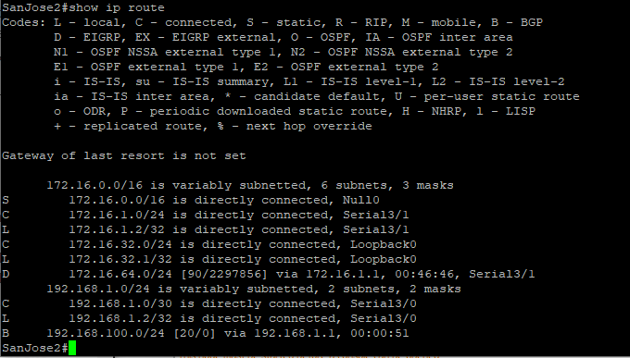
Step 8: Set BGP local preference.

At this point, everything looks good, with the exception of default routes, the outbound flow of data, and inbound packet flow.
- Because the local preference value is shared between IBGP neighbors, configure a simple route map that references the local preference value on SanJose1 and SanJose2. This policy adjusts outbound traffic to prefer the link off the SanJose1 router instead of the metered T1 off SanJose2.
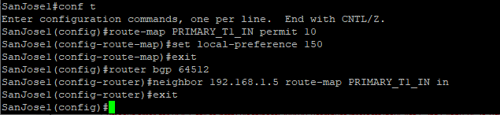
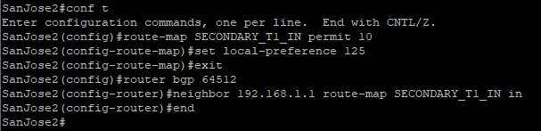
- Use the clear ip bgp * soft command after configuring this new policy. When the conversations have been reestablished, issue the show ip bgp command on SanJose1 and SanJose2.
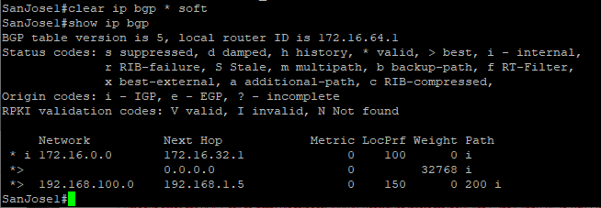

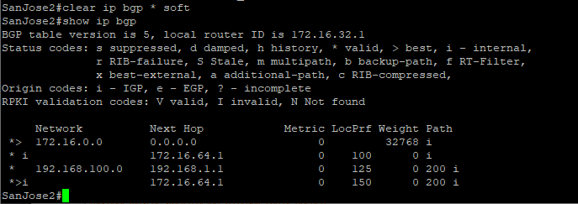

This now indicates that routing to the loopback segment for ISP 192.168.100.0 /24 can be reached only through the link common to SanJose1 and ISP. SanJose2’s next hop to 192.168.100.0/24 is SanJose1 because both routers have been configured using the next-hop-self command.

Step 9: Set BGP MED.

- In the previous step we saw that SanJose1 and SanJose2 will route traffic for 192.168.100.0/24 using the link between SanJose1 and ISP. Examine what the return path ISP takes to reach AS 64512. Notice that the return path is different from the original path. This is known as asymmetric routing and is not necessarily an unwanted trait.
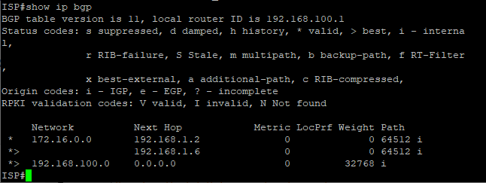
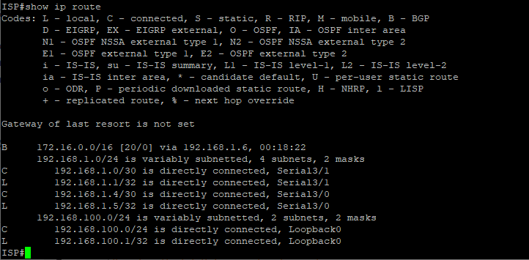

- Use an extended ping command to verify this situation. Specify the record option and compare your output to the following. Notice the return path using the exit interface 192.168.1.1 to SanJose2.
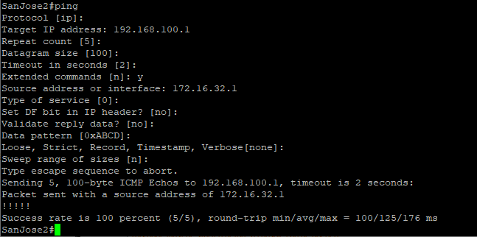
If you are unfamiliar with the record option, the important thing to note is that each IP address in brackets is an outgoing interface. The output can be interpreted as follows:

1. A ping that is sourced from 172.16.32.1 exits SanJose2 through s0/0/1, 172.16.1.2. It then arrives at the s0/0/1 interface for SanJose1.
2. SanJose1 S0/0/0, 192.168.1.6, routes the packet out to arrive at the S0/0/0 interface of ISP.
3. The target of 192.168.100.1 is reached: 192.168.100.1.
4. The packet is next forwarded out the S0/0/1, 192.168.1.1 interface for ISP and arrives at the S0/0/0 interface for SanJose2.
5. SanJose2 then forwards the packet out the last interface, loopback 0, 172.16.32.1.
Although the unlimited use of the T1 from SanJose1 is preferred here, ISP currently takes the link from SanJose2 for all return traffic.
- Create a new policy to force the ISP router to return all traffic via SanJose1. Create a second route map utilizing the MED (metric) that is shared between EBGP neighbors.
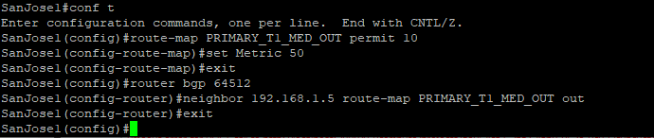
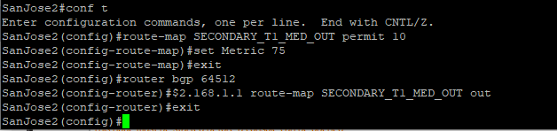
c. Use the clear ip bgp * soft command after issuing this new policy. Issuing the show ip bgp command as follows on SanJose1 or SanJose2 does not indicate anything about this newly defined policy.
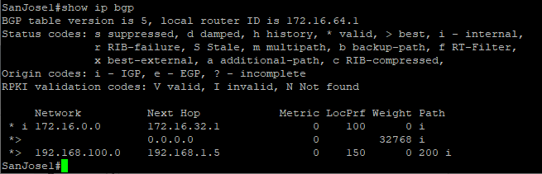
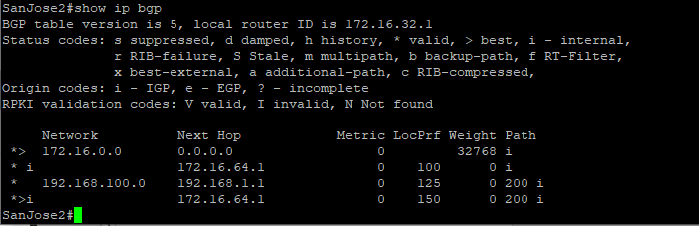
d.Reissue an extended ping command with the record command. Notice the change in return path using the exit interface 192.168.1.5 to SanJose1.

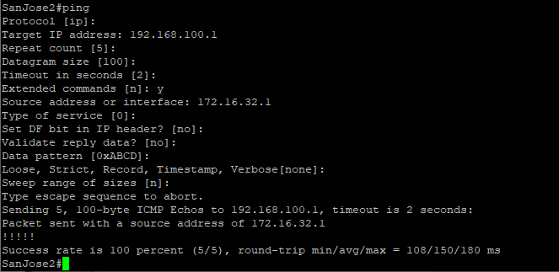
The newly configured policy MED shows that the lower MED value is considered best. The ISP now prefers the route with the lower MED value of 50 to AS 64512. This is just opposite from the local-preference command configured earlier.
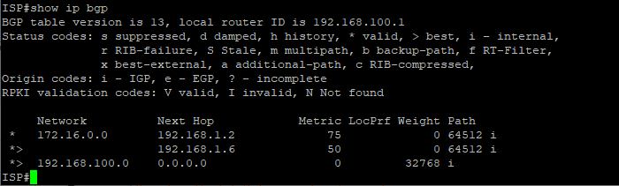

Step 10: Establish a default route.
The final step is to establish a default route that uses a policy statement that adjusts to changes in the network.
- Configure ISP to inject a default route to both SanJose1 and SanJose2 using BGP using the default-originate command. This command does not require the presence of 0.0.0.0 in the ISP router. Configure the 10.0.0.0/8 network which will not be advertised using BGP. This network will be used to test the default route on SanJose1 and SanJose2.
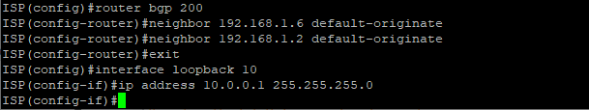
b. Verify that both routers have received the default route by examining the routing tables on SanJose1 and SanJose2. Notice that both routers prefer the route between SanJose1 and ISP.
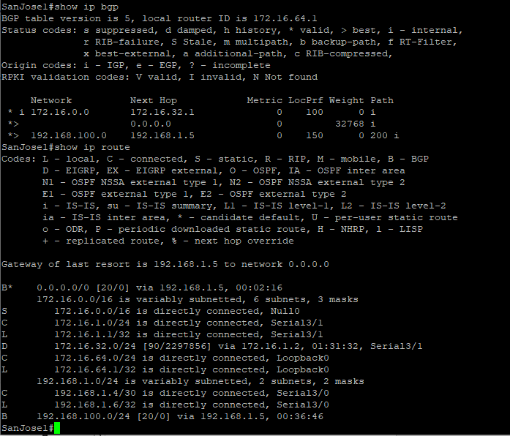
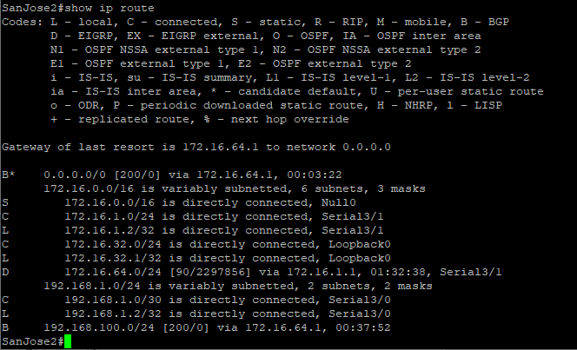
c.The preferred default route is by way of SanJose1 because of the higher local preference attribute configured on SanJose1 earlier.
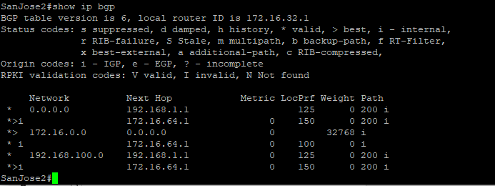
d. Using the traceroute command verify that packets to 10.0.0.1 is using the default route through SanJose1.
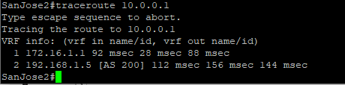
e. Next, test how BGP adapts to using a different default route when the path between SanJose1 and ISP goes down.
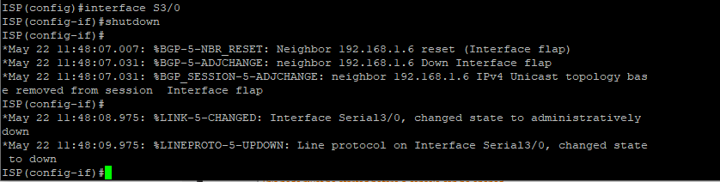
f. Verify that both routers are modified their routing tables with the default route using the path between SanJose2 and ISP.
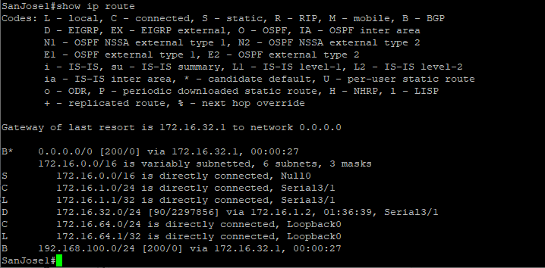
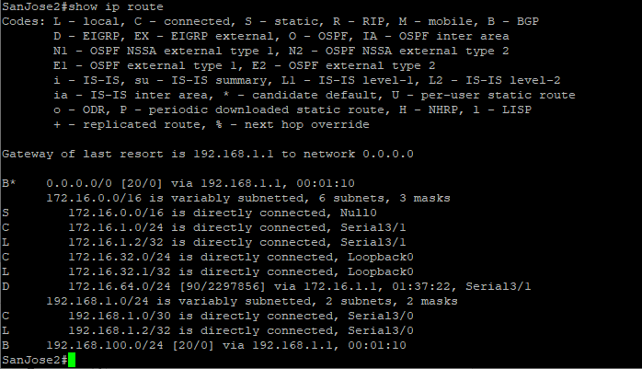
g. Verify the new path using the traceroute command to 10.0.0.1 from SanJose1. Notice the default route is now through SanJose2.
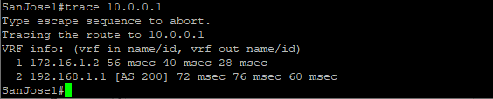

Practical no 4
Aim:- Secure the Management Plane
Topology
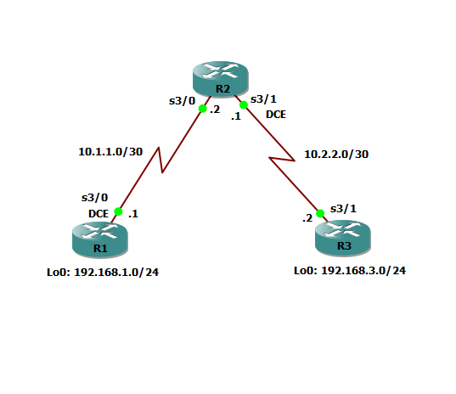

Step 1: Configure loopbacks and assign addresses.
Cable the network as shown in the topology diagram. Erase the startup configuration and reload each router to clear previous configurations. Using the addressing scheme in the diagram, apply the IP addresses to the interfaces on the R1, R2, and R3 routers.
You can copy and paste the following configurations into your routers to begin.
Note: Depending on the router model, interfaces might be numbered differently than those listed. You might need to alter the designations accordingly.

R1
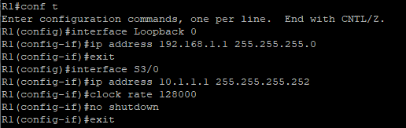
R2
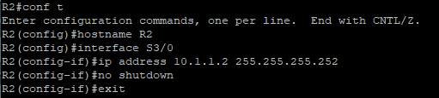
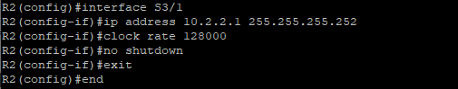
R3
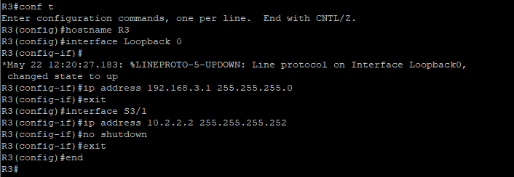
Step 2: Configure static routes.
- On R1, configure a default static route to ISP.
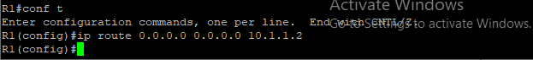
- On R2, configure two static route .
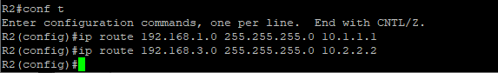
- On R3, configure a default static route to ISP.
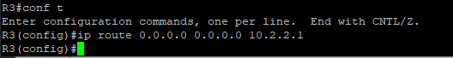
- From the R1 router, run the following Tcl script to verify connectivity.
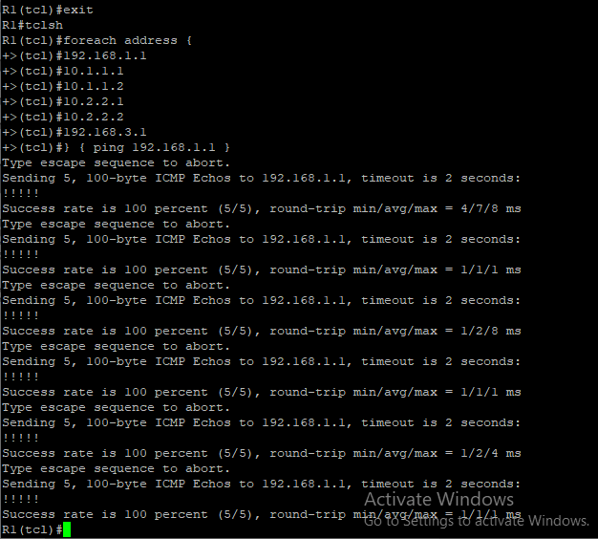

Step 3: Secure management access.
- On R1, use the security passwords command to set a minimum password length of 10 characters.
- Configure the enable secret encrypted password on both routers.
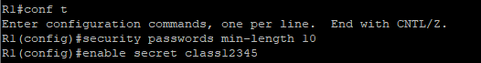
- Configure a console password and enable login for routers. For additional security, the exec-timeout command causes the line to log out after 5 minutes of inactivity. The logging synchronous command prevents console messages from interrupting command entry.
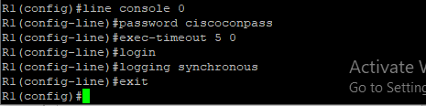
- Configure the password on the vty lines for router R1.
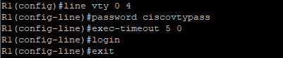
- The aux port is a legacy port used to manage a router remotely using a modem and is hardly ever used.Therefore, disable the aux port.
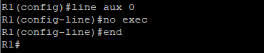
- Enter privileged EXEC mode and issue the show run command. Can you read the enable secret password? Why or why not?
- Use the service password-encryption command to encrypt the line console and vty passwords.
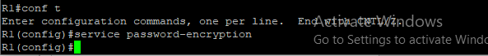

- Configure a warning to unauthorized users with a message-of-the-day (MOTD) banner using the banner motd command. When a user connects to one of the routers, the MOTD banner appears before the login prompt. In this example, the dollar sign ($) is used to start and end the message.

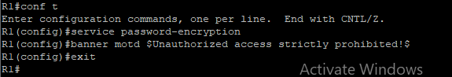

- Repeat the configuration portion of steps 3a through 3k on router R3.

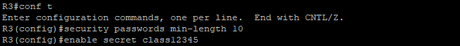

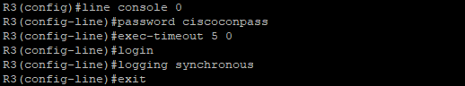

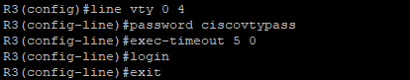

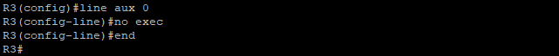

Step 4: Configure enhanced username password security.
- To create local database entry encrypted to level 4 (SHA256), use the username name secret password global configuration command. In global configuration mode, enter the following command:

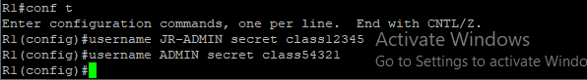

- Set the console line to use the locally defined login accounts.
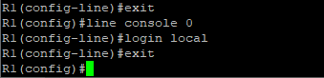
- Set the vty lines to use the locally defined login accounts.
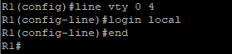
- Repeat the steps 4a to 4c on R3.
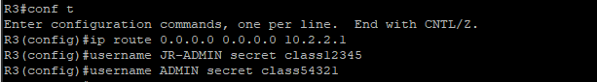
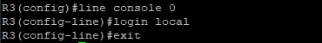
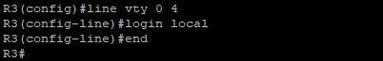
- To verify the configuration, telnet to R3 from R1 and login using the ADMIN local database account.
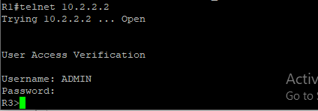
Step 5: Enabling AAA RADIUS Authentication with Local User for Backup.
- Always have local database accounts created before enabling AAA. Since we created two local database accounts in the previous step, then we can proceed and enable AAA on R1.
- Configure the specifics for the first RADIUS server located at 192.168.1.101. Use RADIUS-1-pa55w0rd as the server password.
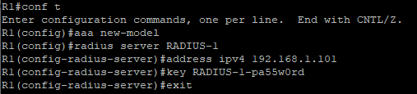
- Configure the specifics for the second RADIUS server located at 192.168.1.102. Use RADIUS-2-pa55w0rd as the server password.
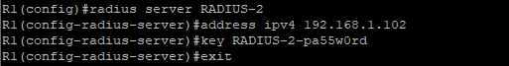
- Assign both RADIUS servers to a server group.
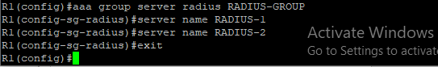
- Enable the default AAA authentication login to attempt to validate against the server group. If they are not available, then authentication should be validated against the local database.
- Enable the default AAA authentication Telnet login to attempt to validate against the server group. If they are not available, then authentication should be validated against a case sensitive local database.
- Alter the VTY lines to use the TELNET-LOGIN AAA authentiaito0n method.
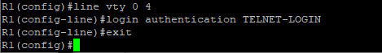
- Repeat the steps 5a to 5g on R3.
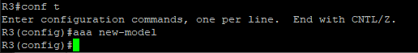
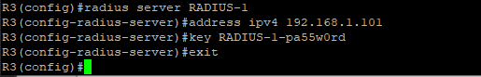
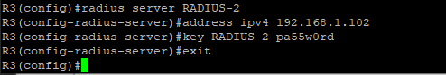
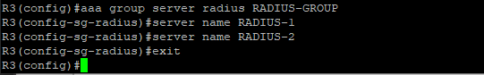
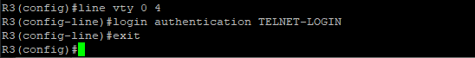
- To verify the configuration, telnet to R3 from R1 and login using the ADMIN local database account.
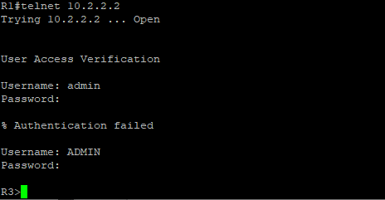

Step 6: Enabling secure remote management using SSH.
- SSH requires that a device name and a domain name be configured. Since the router already has a name assigned, configure the domain name.
- The router uses the RSA key pair for authentication and encryption of transmitted SSH data. Although optional it may be wise to erase any existing key pairs on the router.
- Generate the RSA encryption key pair for the router. Configure the RSA keys with 1024 for the number of modulus bits. The default is 512, and the range is from 360 to 2048.
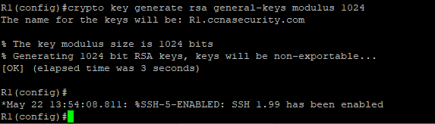
d. Cisco routers support two versions of SSH:
- SSH version 1 (SSHv1): Original version but has known vulnerabilities.
- SSH version 2 (SSHv2): Provides better security using the Diffie-Hellman key exchange and the strong integrity-checking message authentication code (MAC).
Configure SSH version 2 on R1.
e.Configure the vty lines to use only SSH connections.
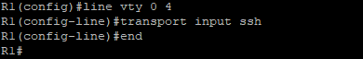
- Verify the SSH configuration using the show ip ssh command.
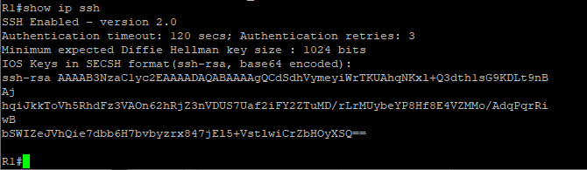
- Repeat the steps 6a to 6f on R3.
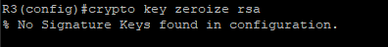
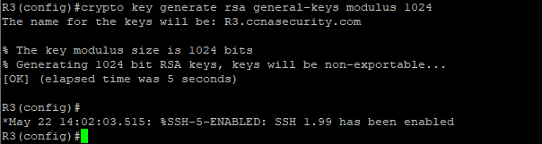
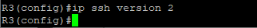
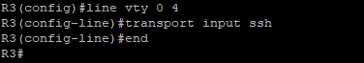
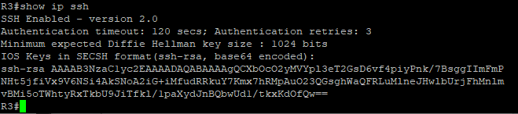

- Although a user can SSH from a host using the SSH option of TeraTerm of PuTTY, a router can also SSH to another SSH enabled device. SSH to R3 from R1.
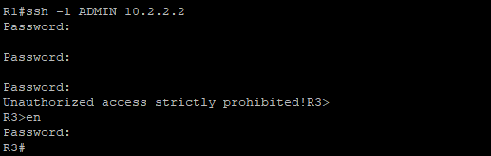

Practical no 5
Aim:- Configure and Verify Path Control Using PBR.
Topology
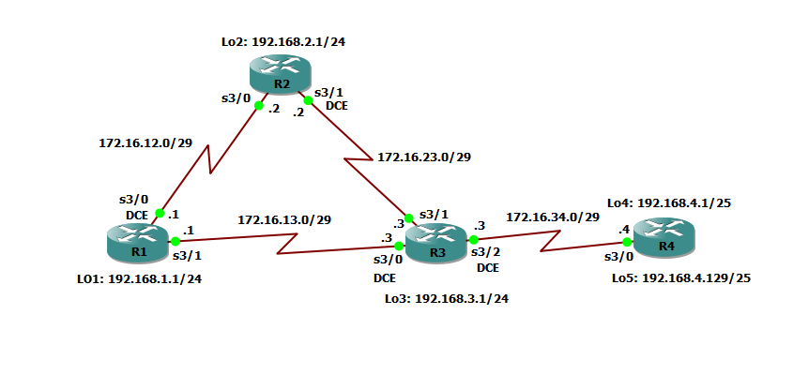

Step 1: Prepare the routers for the lab.
Cable the network as shown in the topology diagram. Erase the startup configuration, and reload each router to clear previous configurations.
Step 2: Configure router hostname and interface addresses.
- Using the addressing scheme in the diagram, create the loopback interfaces and apply IP addresses to these and the serial interfaces on R1, R2, R3, and R4. On the serial interfaces connecting R1 to R3 and R3 to R4, specify the bandwidth as 64 Kb/s and set a clock rate on the DCE using the clock rate 64000 command. On the serial interfaces connecting R1 to R2 and R2 to R3, specify the bandwidth as 128 Kb/s and set a clock rate on the DCE using the clock rate 128000 command.
You can copy and paste the following configurations into your routers to begin.
Router R1
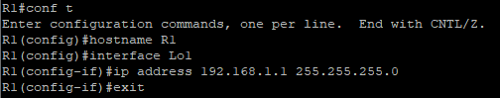
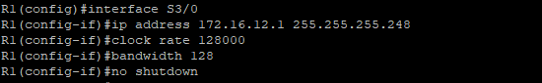
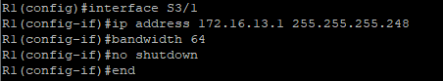
Router R2
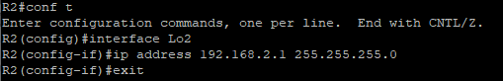
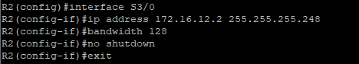
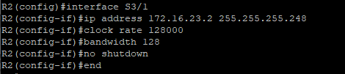
Router R3
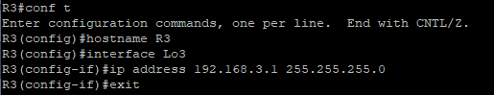
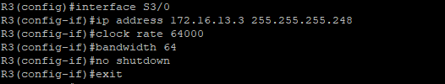
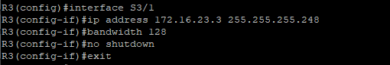
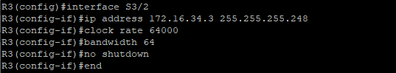
Router R4
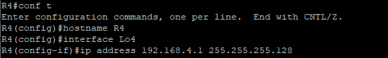
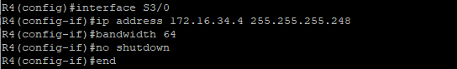
b. Verify the configuration with the show ip interface brief, show protocols, and show interfaces
description commands. The output from router R3 is shown here as an example.
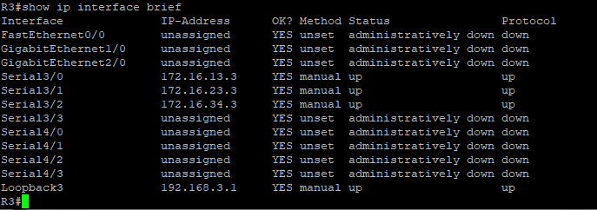
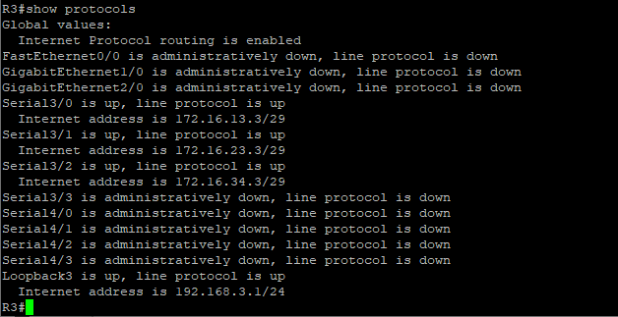
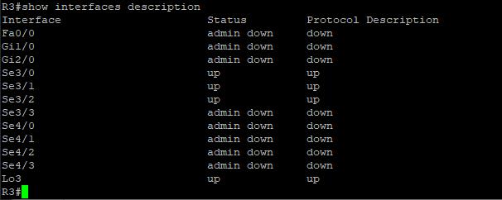
Step 3: Configure basic EIGRP.
a. Implement EIGRP AS 1 over the serial and loopback interfaces as you have configured it for the other EIGRP labs.
b. Advertise networks 172.16.12.0/29, 172.16.13.0/29, 172.16.23.0/29, 172.16.34.0/29, 192.168.1.0/24,192.168.2.0/24, 192.168.3.0/24, and 192.168.4.0/24 from their respective routers.
You can copy and paste the following configurations into your routers.

Router R1
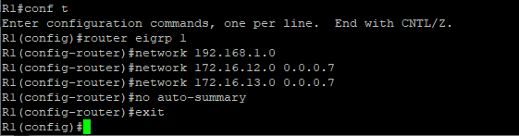
Router R2
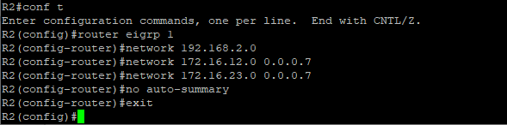
Router R3
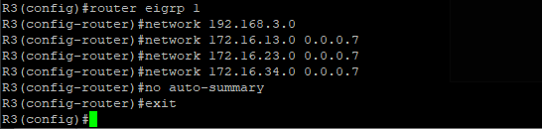
Router R4
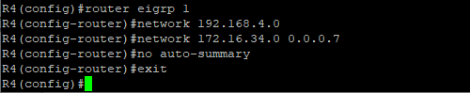
You should see EIGRP neighbor relationship messages being generated.
Step 4: Verify EIGRP connectivity.
- Verify the configuration by using the show ip eigrp neighbors command to check which routers have EIGRP adjacencies.
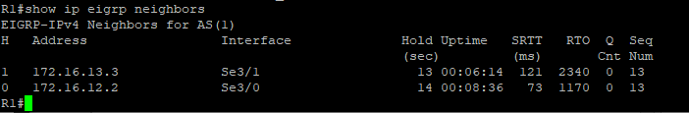
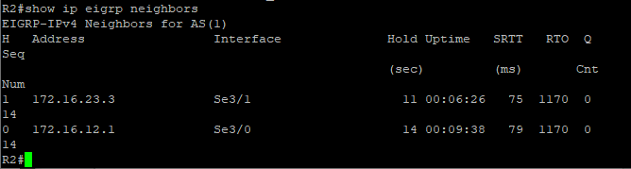
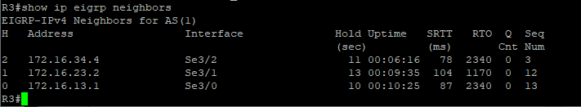
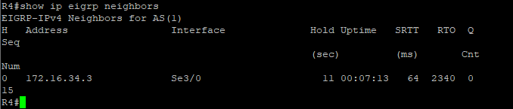

- Run the following Tcl script on all routers to verify full connectivity.
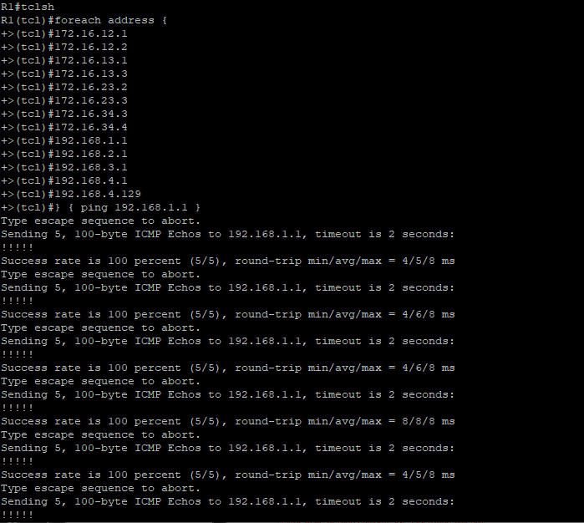
You should get ICMP echo replies for every address pinged. Make sure to run the Tcl script on each router.
Step 5: Verify the current path.
- On R1, use the show ip route command. Notice the next-hop IP address for all networks discovered by EIGRP.
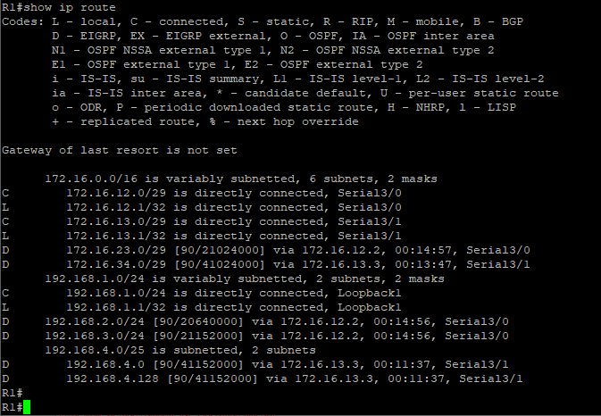
- On R4, use the traceroute command to the R1 LAN address and source the ICMP packet from R4 LAN A and LAN B.
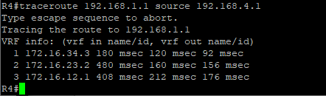
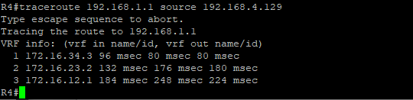

c. On R3, use the show ip route command and note that the preferred route from R3 to R1 LAN
192.168.1.0/24 is via R2 using the R3 exit interface S3/1.
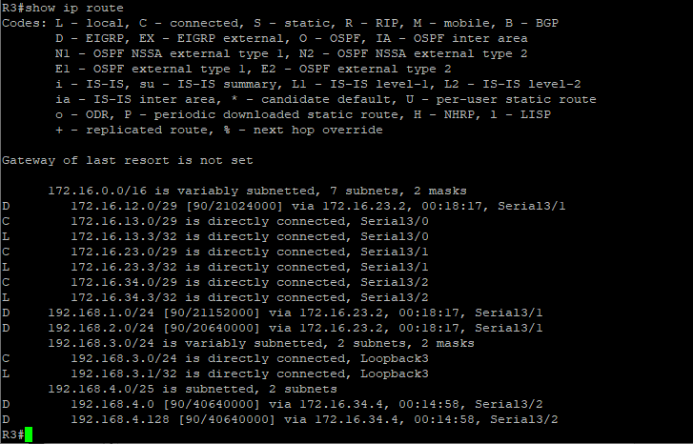
d.On R3, use the show interfaces serial3/0 and show interfaces s3/1 commands.
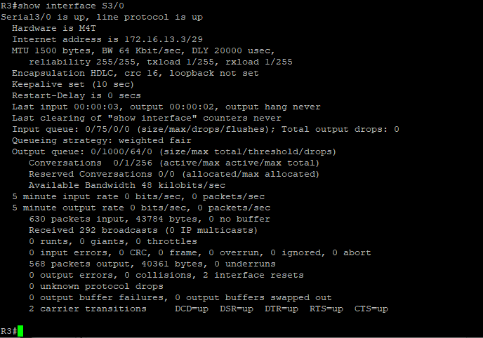

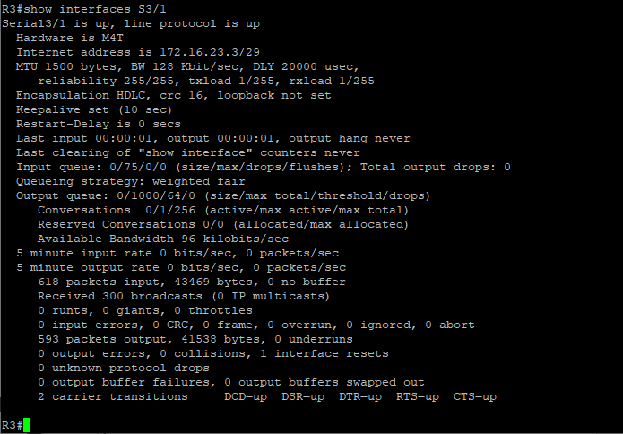
e.Confirm that R3 has a valid route to reach R1 from its serial3/0 interface using the show ip eigrp topology 192.168.1.0 command.
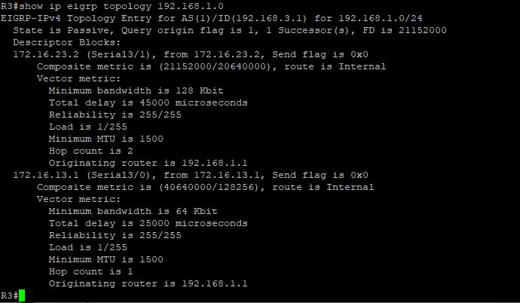
As indicated, R4 has two routes to reach 192.168.1.0. However, the metric for the route to R1 (172.16.13.1) is much higher (40640000) than the metric of the route to R2 (21152000), making the route through R2 the successor route.
Step 6: Configure PBR to provide path control.
- On router R3, create a standard access list called PBR-ACL to identify the R4 LAN B network.
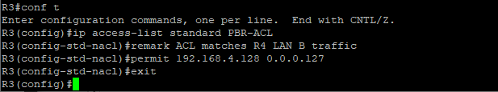
- Create a route map called R3-to-R1 that matches PBR-ACL and sets the next-hop interface to the R1 serial3/1 interface.
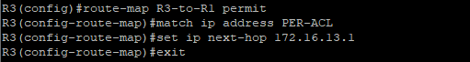
- Apply the R3-to-R1 route map to the serial interface on R3 that receives the traffic from R4. Use the ip policy route-map command on interface S3/2.
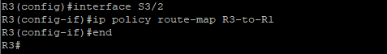
- On R3, display the policy and matches using the show route-map command.
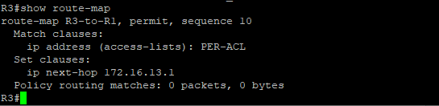

Step 7: Test the policy.
- On R3, create a standard ACL which identifies all of the R4 LANs.
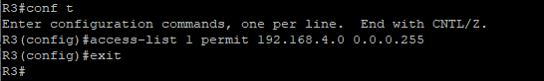
- Enable PBR debugging only for traffic that matches the R4 LANs.
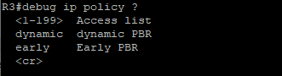
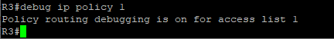
- Test the policy from R4 with the traceroute command, using R4 LAN A as the source network.
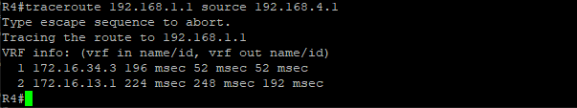
Notice the path taken for the packet sourced from R4 LAN A is still going through R3 --> R2 --> R1.
As the traceroute was being executed, router R3 should be generating the following debug output.
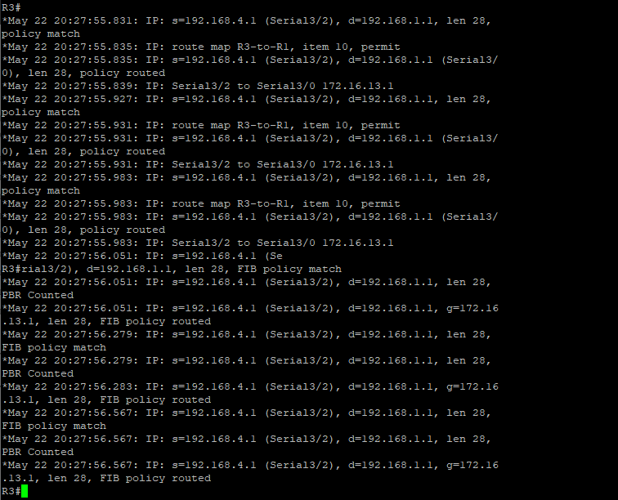

- Test the policy from R4 with the traceroute command, using R4 LAN B as the source network.
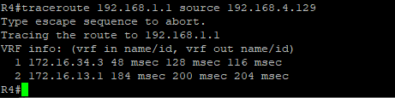
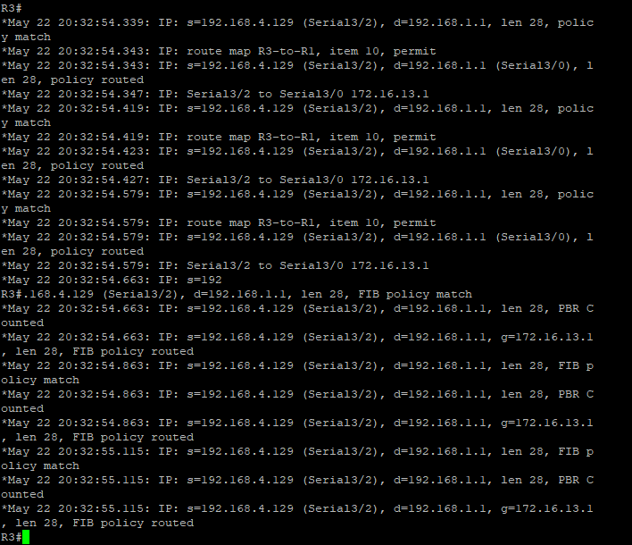
e.On R3, display the policy and matches using the show route-map command.
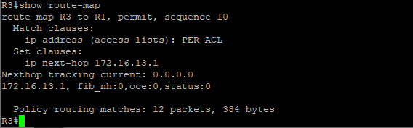

Practical no 6
Aim:- Inter VLAN Routing.
Topology
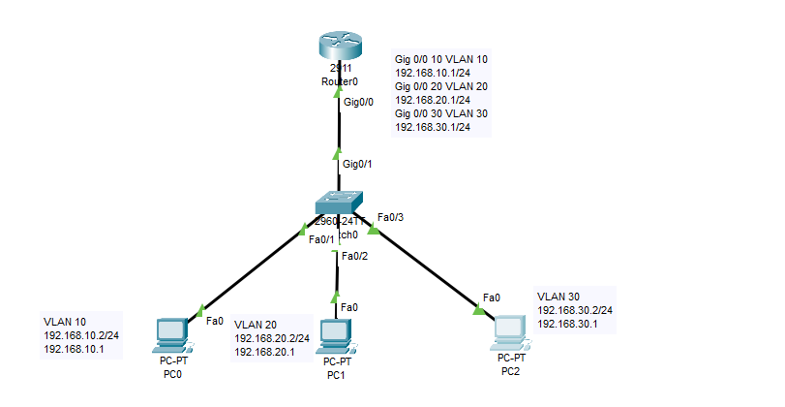

Step 1: Assign the IP Addresses to PCs.
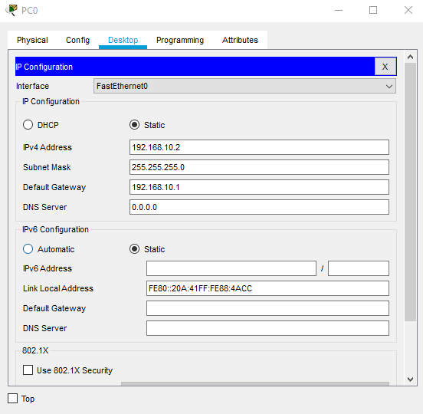
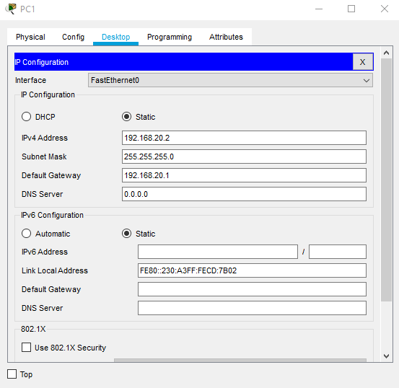
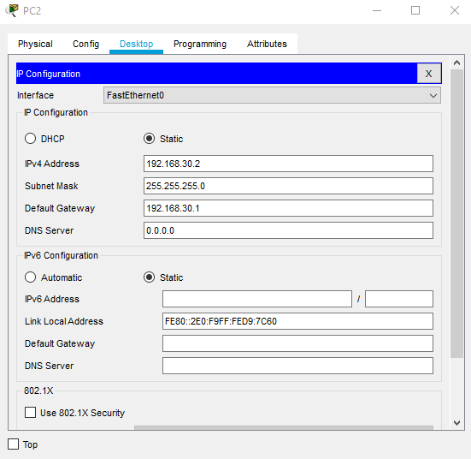
Step 2: Configure within the switch.
- VLAN
- Assign the specified interfaces to the specific VLANs.
- Define access Ports and Trunk Ports.
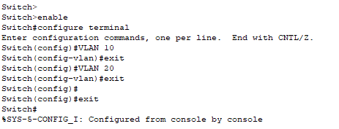
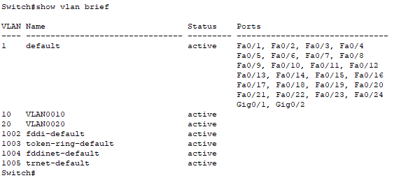

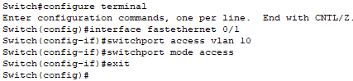
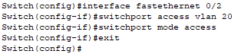
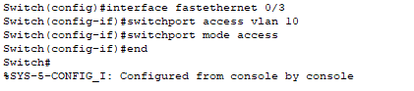
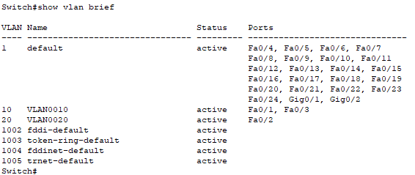
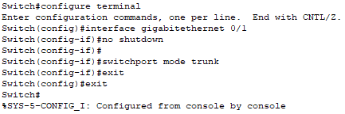
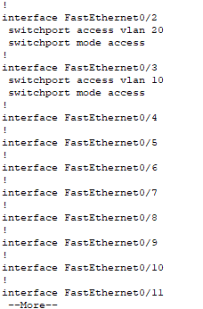
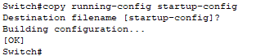

Step 3: Configure router with dot1Q encapsulation by making each of sub-interfaces.
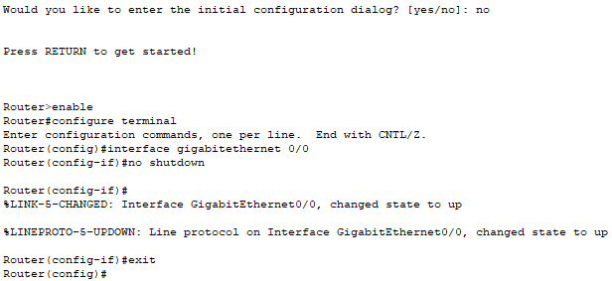
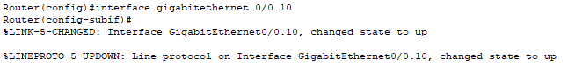
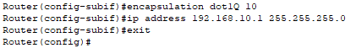
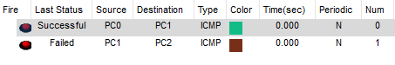
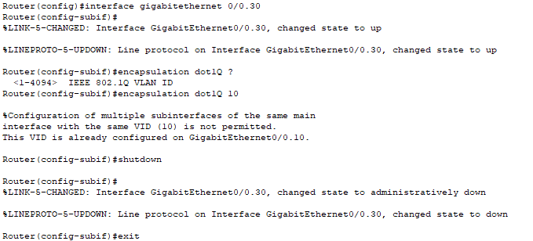
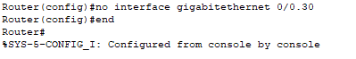
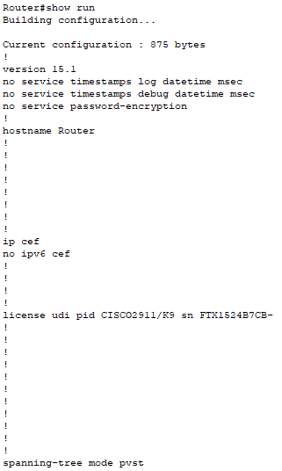

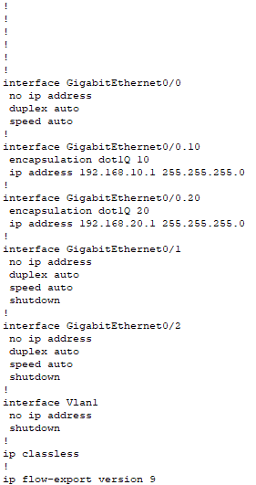
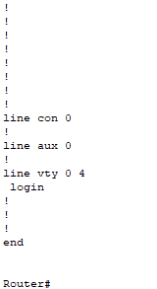
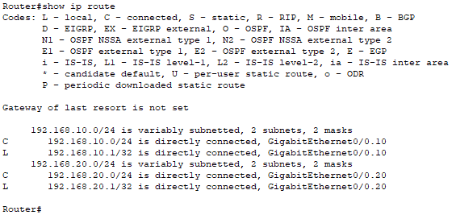
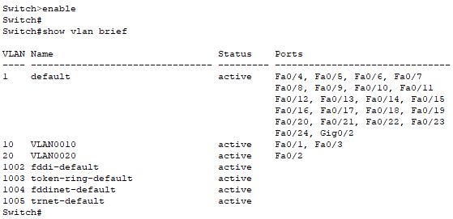
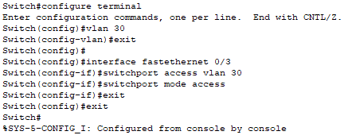
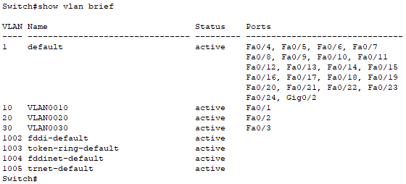
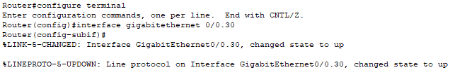
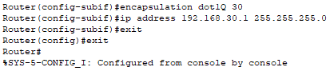
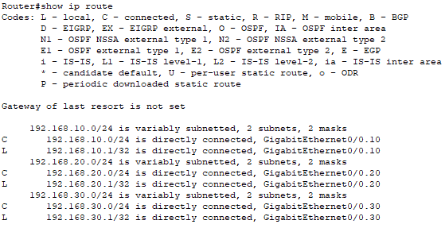

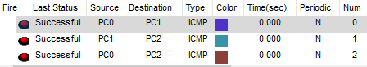
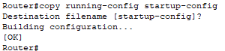
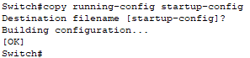
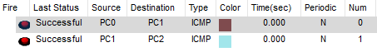
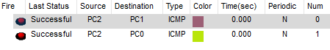

Practical no 7
Aim:- Cisco MPLS Configuration.
Topology
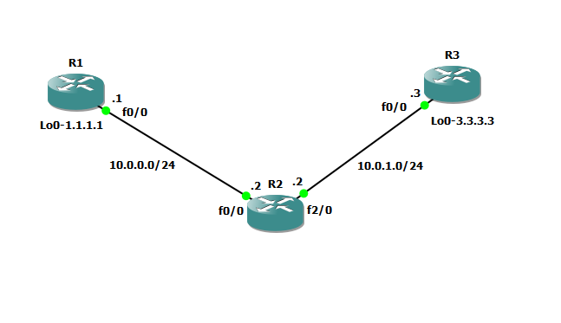

Step 1 – IP addressing of MPLS Core and OSPF
First bring 3 routers into your topology R1, R2, R3 position them as below. We are going to address the routers and configure ospf to ensure loopback to loopback connectivity between R1 and R3.
R1
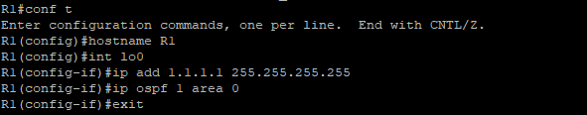
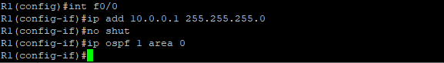

R2
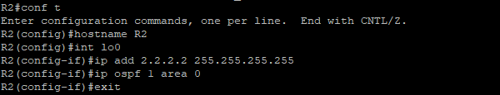
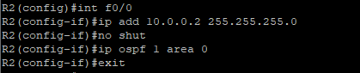
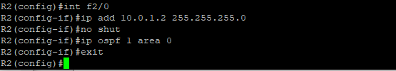
R3
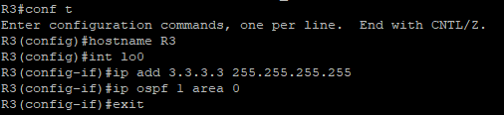
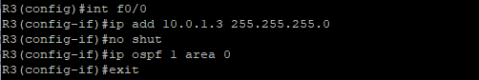
You should now have full ip connectivity between R1, R2, R3 to verify this we need to see if we can ping between the loopbacks of R1 and R3.
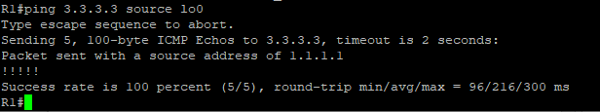
You could show the routing table here, but the fact that you can ping between the loopbacks is verification enough and it is safe to move on.
Step 2 – Configure LDP on all the interfaces in the MPLS Core
In order to run MPLS you need to enable it, there are two ways to do this.
- At each interface enter the mpls ip command
- Under the ospf process use the mpls ldp autoconfig command.
R1
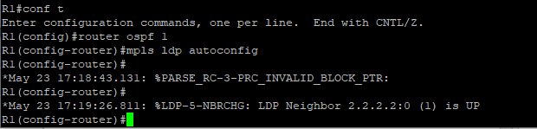
R2
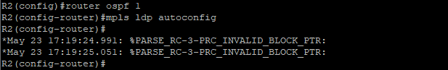
R3
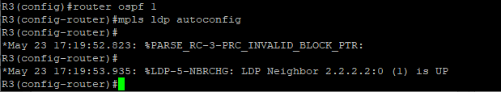
You should see log messages coming up showing the LDP neighbors are up.
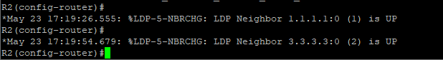
To verify the mpls interfaces the command is very simple – sh mpls interface
This is done on R2 and you can see that both interfaces are running mpls and using LDP.
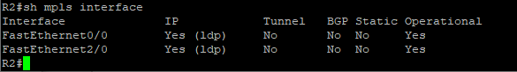
You can also verify the LDP neighbors with the sh mpls ldp neighbors command.
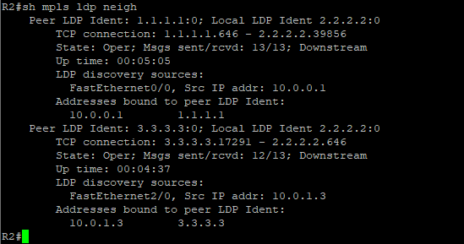
One more verification to confirm LDP is running ok is to do a trace between R1 and R3 and verify if you get MPLS Labels show up in the trace.
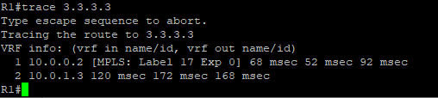
As you can see the trace to R2 used an MPLS Label in the path, as this is a very small MPLS core only one label was used as R3 was the final hop.
So to review we have now configured IP addresses on the MPLS core, enabled OSPF and full IP connectivity between all routers and finally enabled mpls on all the interfaces in the core and have established ldp neighbors between all routers.
The next step is to configure MP-BGP between R1 and R3.
This is when you start to see the layer 3 vpn configuration come to life.
Step 3 – MPLS BGP Configuration between R1 and R3
We need to establish a Multi Protocol BGP session between R1 and R3 this is done by configuring the vpnv4 address family as below.
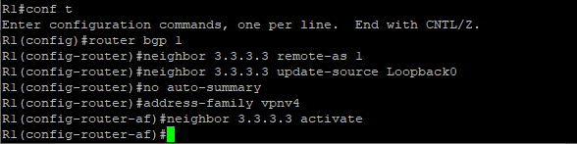
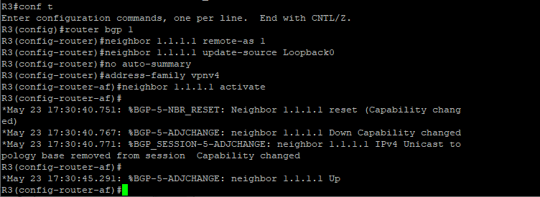
You should see log messages showing the BGP sessions coming up.
To verify the BGP session between R1 and R3 issue the command sh bgp vpnv4 unicast all summary.
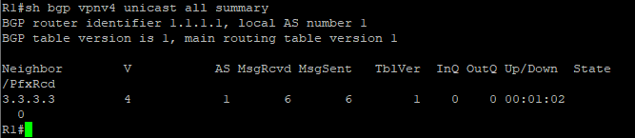
You can see here that we do have a bgp vpnv4 peering to R3 – looking at the PfxRcd you can see it says 0 this is because we have not got any routes in BGP. We are now going to add two more routers to the topology. These will be the customer sites connected to R1 and R3. We will then create a VRF on each router and put the interfaces connected to each site router into that VRF.

Step 4 – Add two more routers, create VRFs.
We will add two more routers into the topology so it now looks like the final topology
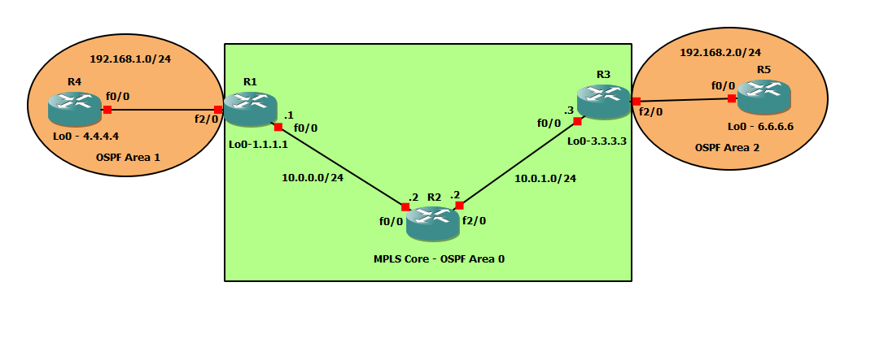
Router 4 will peer OSPF using process number 2 to a VRF configured on R1. It will use the local site addressing of 192.168.1.0/24.
R4
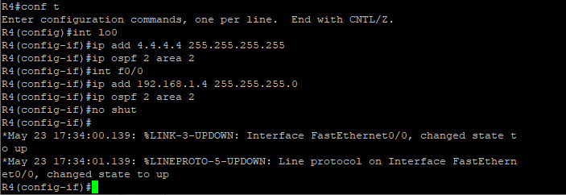
R1
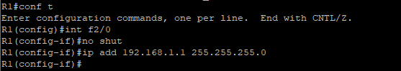

Now at this point we have R4 peering to R1 but in the global routing table of R1 which is not what we want.
We are now going to start using VRF’s.
For this mpls tutorial I will be using VRF RED.
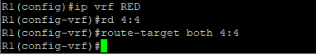So now we have configured the VRF on R1 we need to move the interface F0/1 into that VRF.
You just need to re-apply it
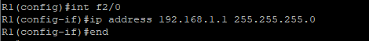
Now if we view the config on R1 int f2/0 you can see the VRF configured.
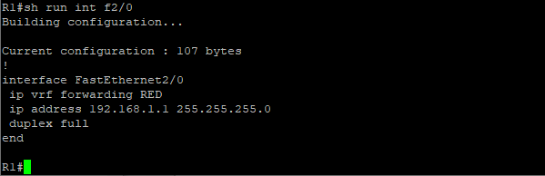
Now we can start to look int VRF’s and how they operate – you need to understand now that there are 2 routing tables within R1
- The Global Routing Table
- The Routing Table for VRF RED
If you issue the command sh ip route this shows the routes in the global table and you will notice that you do not see 192.168.1.0/24
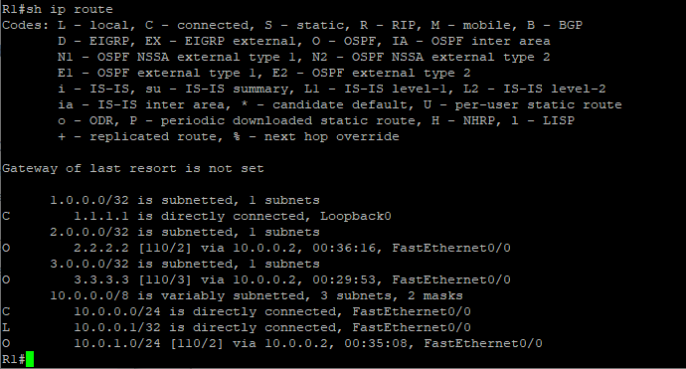
If you now issue the command sh ip route vrf red – this will show the routes in the routing table for VRF RED.
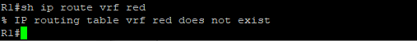
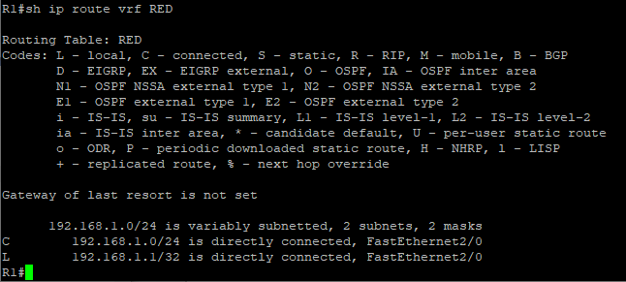

We just need to enable OSPF on this interface and get the loopback address for R4 in the VRF RED routing table before proceeding.
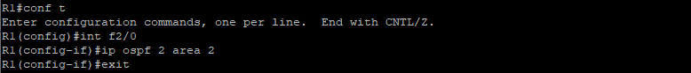
You should see a log message showing the OSPF neighbor come up.
If we now check the routes in the VRF RED routing table you should see 4.4.4.4 in there as well.
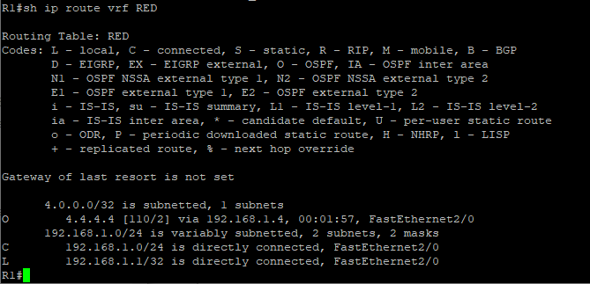

We now need to repeat this process for R3 & R5
Router 6 will peer OSPF using process number 2 to a VRF configured on R3. It will use the local site addressing of 192.168.2.0/24.
R5
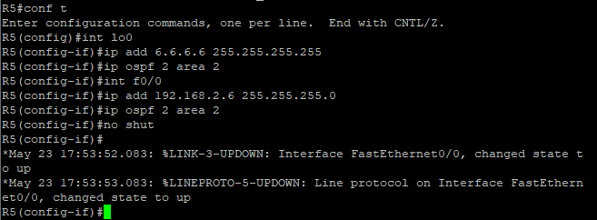
R3
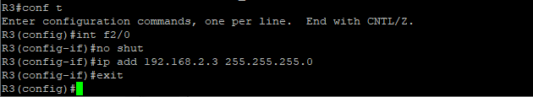
We also need to configure a VRF onto R3 as well.
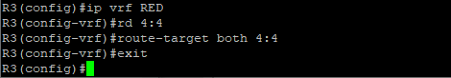
So now we have configured the VRF on R3 we need to move the interface F0/1 into that VRF.
Now notice what happens when you do that – the IP address is removed.

You just need to re-apply it.
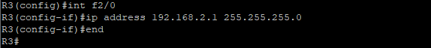
Now if we view the config on R3 int f2/0 you can see the VRF configured.
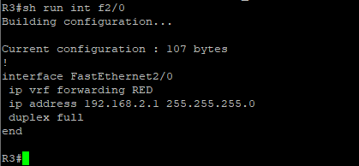
Finally we just need to enable OSPF on that interface and verify the routes are in the RED routing table.
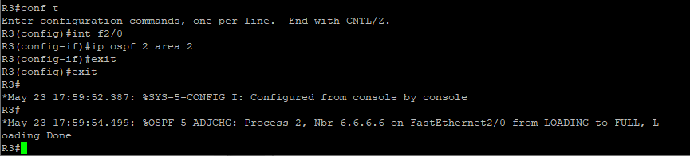
Check the routes in vrf RED
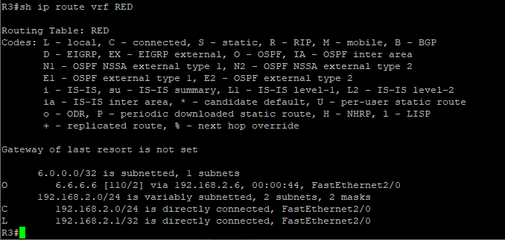
The final step to get full connectivity across the MPLS core is to redistribute the routes in OSPF on R1 and R3 into MP-BGP and MP-BGP into OSPF, this is what we are going to do now.
We need to redistribute the OSPF routes from R4 into BGP in the VRF on R1, the OSPF routes from R6 into MP-BGP in the VRF on R3 and then the routes in MP-BGP in R1 and R3 back out to OSPF.

Before we start lets do some verifications
Check the routes on R4
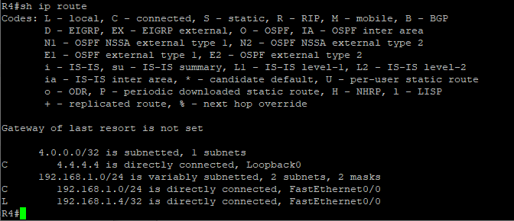
As expected we have the local interface and the loopback address.
When we are done we want to see 6.6.6.6 in there so we can ping across the MPLS

Check the routes on R1
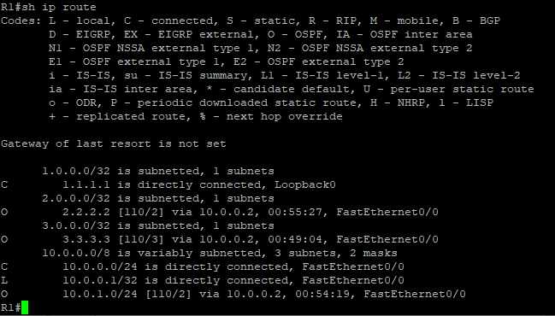
Remember we have a VRF configured on this router so this command will show routes in the global routing table (the MPLS Core) and it will not show the 192.168.1.0/24 route as that is in VRF RED – to see that we run the following command.
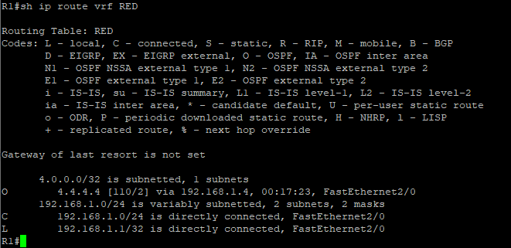

Here you can see Routing Table: RED is shown and the routes to R4 are now visible with 4.4.4.4 being in OSPF.
So we need to do the following;
- Redistribute OSPF into MP-BGP on R1
- Redistribute MP-BGP into OSPF on R1
- Redistribute OSPF into MP-BGP on R3
- Redistribute MP-BGP into OSPF on R3
Redistribute OSPF into MP-BGP on R1
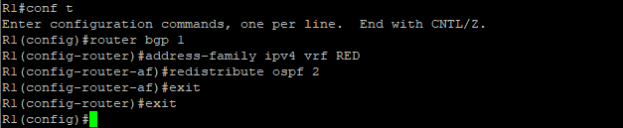
Redistribute OSPF into MP-BGP on R3
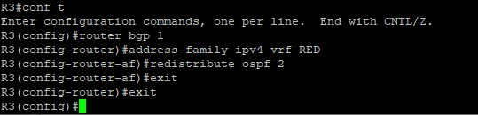
This has enabled redistribution of the OSPF routes into BGP. We can check the routes from R4 and R6 are now showing in the BGP table for their VRF with this command
sh ip bgp vpnv4 vrf RED
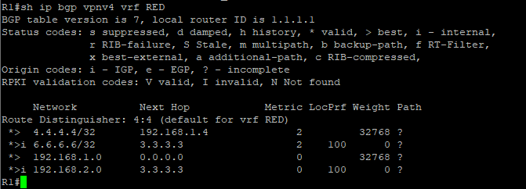
Here we can see that 4.4.4.4 is now in the BGP table in VRF RED on R1 with a next hop of 192.168.1.4 (R4) and also 6.6.6.6 is in there as well with a next hop of 3.3.3.3 (which is the loopback of R3 – showing that it is going over the MPLS and R1 is not in the picture)
The same should be true on R3.
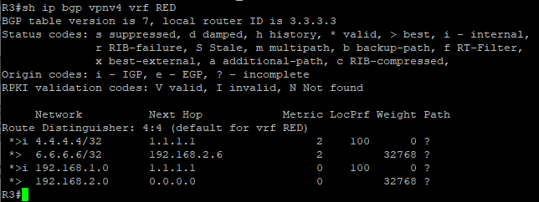
Which it is! 6.6.6.6 is now in the BGP table in VRF RED on R3 with a next hop of 192.168.2.6 (R6) and also 4.4.4 is in there as well with a next hop of 1.1.1.1 (which is the loopback of R1 – showing that it is going over the MPLS and R2 is not in the picture)
The final step is to get the routes that have come across the MPLS back into OSPF and then we can get end to end connectivity.
R1
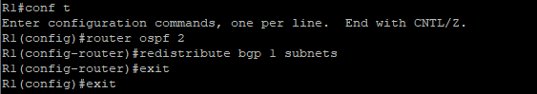
R3
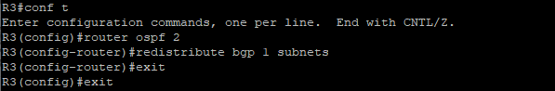

If all has worked we should be now able to ping 6.6.6.6 from R4
Before we do let’s see what the routing table looks like on R4.
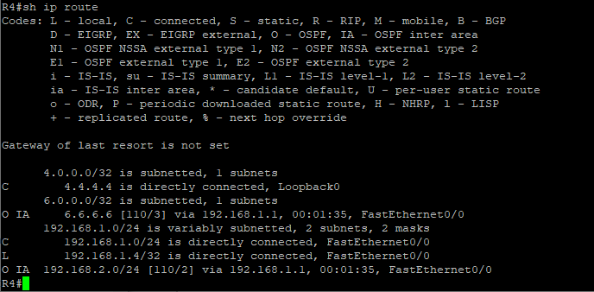
Great we have 6.6.6.6 in there
Also check the routing table on R5.
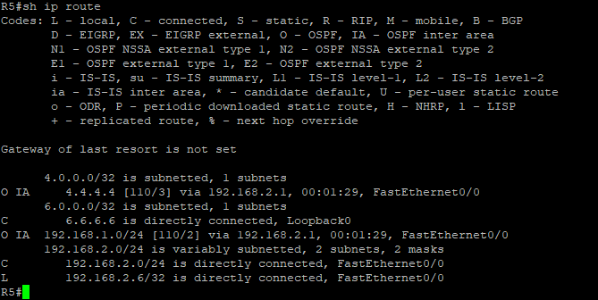

Brilliant we have 4.4.4.4 in there so we should be able to ping across the MPLS.
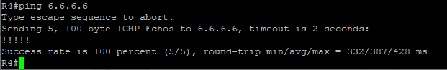
Which we can – to prove this is going over the MPLS and be label switched and not routed, lets do a trace.
